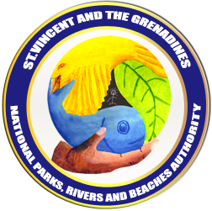
OCTOBER, 2009

NATIONAL PARKS AND PROTECTED AREAS

SYSTEM PLAN
2009 - 2014

ST. VINCENT AND THE GRENADINES
NATIONAL PARKS, RIVERS AND BEACHES AUTHORITY

Table of Contents

Glossary . . . . . . . . . iii

Preface . . . . . . . . . iv

Executive Summary . . . . . . . . v

- Introduction . . . . . . . . 1
  - Rationale for the System . . . . . 2
  - Objectives of the System . . . . . 5
  - National Parks and Protected Areas Policy . . . 7

- Sites . . . . . . . . . 11
2.1 Existing Sites . . . . . . . 11
2.2 Proposed Sites . . . . . . 15
2.3 International Designation . . . . . 23
2.4 Declaration and development of sites . . . 26

- Legal and Institutional Arrangements . . . . 27
3.1 Legislation . . . . . . . 27
3.2 International Conventions and Agreements . . . 31
3.3 Institutions . . . . . . . 34

- Management . . . . . . . . 36
4.1 System Management . . . . . . 36
4.1.1 Protected Areas Policy . . . . 36
4.1.2 National Parks and Protected Areas System Plan . 36
4.1.3 Protected Areas Declaration . . . . 36
4.1.4 Protected Areas Management Plans . . . 36
4.1.5 Training and Technical Assistance . . . 37
4.1.6 Standard Operating Procedures . . . 37
4.1.7 Monitoring and Evaluation of the System . . 37
4.1.8 Research & Development . . . . 38
4.1.9 Promotion (marketing and public awareness) . . 38
4.1.10 Financing . . . . . . 38
4.1.11 Rivers (watersheds) . . . . . 38
4.1.12 Beaches (recreation) . . . . . 39
4.1.13 Laws, Regulations and Enforcement . . . 39
4.1.14 MoUs for System Management . . . 39
4.2 Site Management . . . . . . 40
4.2.1 Management and Operations . . . . 40
4.2.2 MoUs for day-to-day site management . . 42
4.2.3 Management Plan . . . . . 42

- Financing . . . . . . . . 43
5.1 Financial Mechanisms . . . . . 43
5.1.1 Multilateral Funding . . . . . 43
5.1.2 Bilateral Funding . . . . . 44
5.1.3 Protected Area User Fee System . . . 44
5.1.4 Government Contribution . . . . 44
5.1.5 Airport Fee . . . . . . 45
5.1.6 Cruise Ship Fee . . . . . 45
5.1.7 Trust Fund . . . . . . 45
5.1.8 Donations . . . . . . 46
5.1.9 Payment for Environmental Services . . . 46

- Monitoring and Evaluation . . . . . . 48
6.1 Performance Evaluation . . . . . 48
6.1.1 Monitoring . . . . . . 48
6.1.2 Auditing . . . . . . 48
6.1.3 Customer Feedback . . . . . 49
6.2 Analysis and Evaluation . . . . . 49
6.3 Annual Reports . . . . . . 49
6.4 System Plan Review . . . . . . 49

Bibliography

List of Figures
Figure 2.1: Map of existing protected areas . . . . . 10
Figure 2.2: Map of proposed sites . . . . . . 17

List of Tables
Table 1.1: List of international environmental Conventions and Agreements 6
Table 2.1: Existing Protected Areas . . . . . . 9
Table 2.2: Recommended Sites for the SVG SPA (Jackson, 2004) . . 13
Table 2.3: Protected Areas in the proposed System for SVG . . . 15
Table 2.4: IUCN protected areas management categories . . . 22
Table 2.5: IUCN classification of the proposed protected areas for SVG . 23
Table 4.1: Site management functions . . . . . 39

Glossary

CBD - Convention on Biological Diversity
CBO - Community Based Organisation
CEHI - Caribbean Environmental Health Institute
CERMES - Centre for Resources Management and Environmental Studies
COP7 - 7th Conference of the Parties
CWSA - Central Water and Sewerage Authority
GEF - Global Environment Facility
IUCN - World Conservation Union
MoT - Ministry of Tourism
MoU - Memorandum of Understanding
NBSAP - National Biodiversity Strategy and Action Plan
NGO - Non-Government Organization
NISP - Protected Area National Implementation Support Partnership
NLTA - North Leeward Tourism Association
NPA - National Parks Rivers & Beaches Authority
OPAAL - OECS Protected Areas and Associated Livelihoods Project
PoW - Global Programme of Work on Protected Areas
PSU - Project Support Unit
SOP - Standard Operating Procedure
SVG - St. Vincent and the Grenadines
TCMP - Tobago Cays Marine Park
TDP - Tourism Development Project
UNCED - United Nations Conference on Environment and Development
VINLEC - Saint Vincent Electric Services Limited
WCPA - World Commission on Protected Areas
WHC - Convention Concerning the Protection of the World Cultural and Natural
Heritage ((World Heritage Convention)

Preface

While the author, working under the ambit of the Tourism Development Project executed by the Ministry of Tourism and implemented by the National Parks Rivers & Beaches Authority, accepts responsibility for the contents of this document, the production of this document would not have been possible without the involvement of the major stakeholders.

The System Plan builds on the studies and reports that predate this document and the ideas and issues of relevance were discussed with the major stakeholders (government, private sector, NGO and CBO sectors) prior to drafting. The production of this document used an iterative approach involving a multi-disciplinary and multi-agency review team.

The review team was made up of the following persons:

Herman Belmar, Sandwatch and Sustainable Livelihoods
Vida Bernard, Director of Tourism, Ministry of Tourism
Hayden Billingy, Superintendent Rivers, Beaches & Recreation Sites, NPA
Anthony Bowman, Physical Planning
Edmund Jackson, Environmental Services Unit, Ministry of Health
Brian Johnson, Director of Forestry, Forestry Department
Kathy Martin, Director, SVG National Trust
Howie Prince, National Emergency Management Organisation
Fitzgerald Providence, Integrated Forestry Project, Forestry Department
Sophia Punnett, Fisheries Division
Fr. Andrew Roache, Marine Parks Board
Raymond Ryan, Chief Fisheries Officer, Fisheries Division
Andrew Simmons, Coordinator, National Implementation Support Partnership
Andrew Wilson, Director, NPA

Further support and comments were received from:

Christobel Ashton, Project Support Unit
Ruth Blyther, TNC
Vera Ann Brereton, Project Support Unit
Vidal Browne, NPA Chairman
Mrs. Laverne Grant, PS Ministry of Tourism
Gernot Ott, Project Support Unit

The review team commented on each chapter of the System Plan as they were drafted. Their comments were used to ultimately develop a first draft of the Plan. This draft was then subject to a final drafting workshop involving the review team. The resulting draft was submitted to the NPA for approval for public release. Upon which the System Plan was presented at 5 public consultations (Leeward, Windward, Kingstown, Northern Grenadines – Bequia, and Southern Grenadines – Union Island). This allowed for further public and key stakeholder input before finalisation and final submission to the Board of the National Parks Rivers & Beaches Authority for approval.
Executive Summary

The Government of St. Vincent and the Grenadines (SVG) in response to the economic decline in the banana industry has made the strategic decision to fill the void in the national economy by strategically targeting the growth of the tourism sector. In particular, it will attempt to deepen and broaden the industry by diversifying the tourism product. The tourism product, at present, is mainly confined to the Grenadines and is the typical sun, sea, and white sand beaches Caribbean experience. The main island, St. Vincent, where the effects of the declining banana industry is directly felt, has none of these attributes. However, there are features that could be used to develop a different kind of tourism experience (waterfalls, biodiversity, black sand beaches, volcano, forests, petroglyphs, cultural and historical sites, etc.).

A National Park and Protected Areas System is a most practical mechanism to address the concerns of sustainable tourism and the attendant environmental issues in an integrated and holistic way. It is out of this growing recognition of the nexus between tourism and the environment and the linkages to enhanced rural development that the Government is seeking over the medium term to develop the institutional capacity to implement a comprehensive master plan for tourism development, management and operation of designated sites, protected areas, recreational sites, and natural and Man-made attractions. This is to be done in collaboration with the communities within close proximity to the designated sites.

One of the main efforts involved with the development of the tourism sector is the Tourism Development Project (TDP) which is funded by the Government of SVG and the European Union. It is being executed through the Ministry of Tourism and implemented by the National Parks Authority (NPA) which is supported by a Project Support Unit (PSU). The project seeks to develop community based tourism at 14 sites with significant biodiversity, rich cultural and historical heritage, and recreational potential. The TDP will achieve this by:

- Upgrading and developing infrastructure at 14 designated sites.

- Developing a National Parks System the components of which are:
  - Building capacity of CBOs to undertake local management of the sites
  - Assisting with the development and strengthening of the recently launched National Parks Authority.
  - Development of an SVG National Parks and Protected Areas System Plan through a collaborative process which includes public participation.
  - Development of MoUs between the NPA and the key stakeholders (government, NGOs, and CBOs)
  - Developing the Regulations and Orders for the National Parks Act 2002.
  - Development of a Financing Plan for the SVG National Parks System.
  - Develop a monitoring and auditing system for the NPA

- Develop and implement a marketing programme for the designated sites

Special Features of SVG Protected Areas
The Eastern Caribbean nation of St. Vincent and the Grenadines (SVG) consists of the main island of St. Vincent (345 km²), and the Grenadines (44 km²) which includes the islands of Bequia, Mustique, Canouan, Mayreau, Union Island, Palm Island, Petit St. Vincent, and 28 uninhabited islets. The combined population of SVG is approximately 120,000 people.

SVG boasts a diverse collection of biological resources. St. Vincent is rugged and mountainous with steep slopes and fertile yellow earth, volcanic ash and alluvial soils. The country has about 12,700 ha of tropical forests, including primary and secondary rainforest, palm brakes, elfin woodland, littoral woodland, dry scrub woodlands and mangrove forest. The significant tropical forests provide natural habitat for wildlife including the St. Vincent parrot and other endemic species. The Grenadines, in contrast, consists of low dry islands surrounded by extensive coral reefs and sea grass beds. These ecosystems are home to significant biodiversity including several endemic species. SVG is committed to the worldwide effort to conserve biodiversity as enshrined in the Convention on Biological Diversity (CBD).

Heritage is wide ranging in scope, encompassing the natural (living and non-living), cultural and traditional aspects of human existence. Aspects of SVG’s heritage that informs and prescribes the aims and scope of management for protected areas and heritage sites include:
- People
- Boat, seafaring and other maritime traditions
- Amerindian, African and European contributions and artefacts in particular the petroglyphs (rock art) which is recognised and protected under the Convention Concerning the Protection of the World Cultural and Natural Heritage otherwise called the World Heritage Convention (WHC)
- Architecture and engineering as evidenced from historic buildings (churches, homes), industrial ruins, military facilities and fortifications
- Accounts of rediscovery and resistance
- Biological diversity and genetic resources
- Rivers and waterfalls
- Scenic landscapes
- Beaches and scenic coastlines
- Coral reefs
- Song, music and dance

The citizens of SVG have over the years have utilized the natural environment for their own recreation. These include beaches, waterfalls, forests, hiking trails, rivers. Recreational activities include cook outs and picnics, bathing and swimming, fishing, hiking, etc. Recreation is necessary for the rebuilding of the human spirit and important to the psyche of the people.

The Protected Areas System must address the preservation and sustainable use of the natural and cultural resources first and fore mostly for the people of SVG, and in so doing recognize that visitors to the country would wish to enjoy what is uniquely “Vincy”.

The development of SVG’s tourism product utilising the country’s natural and cultural heritage is in line with the efforts being spearheaded by the Ministry of Tourism. Tourism appropriate to heritage conservation and appreciation will be encouraged so as to achieve economic and social benefits critical to improving the standard and quality of living for citizens of the country.

Management Objectives
A protected area is an area of land or water that is managed for the protection and maintenance of its ecological systems, biological diversity and or specific natural, cultural and aesthetic resources. The SVG Protected Areas System will embrace principle aims agreed by the international community for the management of protected areas. These include scientific research, wilderness protection and landscape maintenance, preservation of species and genetic diversity, maintenance of environmental services, protection of specific natural features, promotion of recreation and tourism, education, sustainable use of natural ecosystems and maintenance of cultural and traditional attributes.

Specifically, the System will be managed to achieve the following objectives:
- Sustainable development
- Protection of biodiversity
- Protection of culture and heritage
- Development of recreational sites
- Protection of ecosystem function (e.g. water, electricity, soil conservation, etc.)
- Meeting obligations under international conventions
- Development of tourism through diversification
- Financial sustainability
- Research

Policy
A Policy for the SVG National Parks and Protected Areas System is developed as part of the creation of this document and is presented. The draft Policy Statement builds on existing legal instruments (Laws) and practices for resource protection and management within SVG. Such Laws are clear in their intention to protect soil, water, plants and animals, all of which are critical to sustaining economic growth and social benefits. The policy is also strategically, logically and practically linked to development policies for critical economic sectors, such as tourism, fishing, forestry, water and energy.

Sites that make up the System
The Government of SVG places top priority on the conservation and sustenance of its biodiversity. To date, the government has established 35 existing legally designated protected area sites in SVG (Jackson, 2002) using a number of different legislation that includes the Forest Resources Conservation Act (1992), the Wildlife Protection Act (1987), and the Fisheries Act (1986).

Over the years, sites have been proposed for inclusion in the SVG Protected Areas System. The suggestions were made because of unique or special ecological, biodiversity, historical, cultural, recreational, tourism or aesthetic attributes that exist at the proposed site. These included suggestions for changes in site designations and classifications.

Taking into consideration all the opinions and studies done over the years, a total of 75 sites have been proposed that would comprise the SVG National Parks and Protected Areas System and are listed in the table below. These sites are not by any means exclusive. Any other site may be proposed in writing to the NPA at any time, upon which a technical analysis would be carried out for the NPA Board’s consideration.

It is important that the sites in the SVG Parks and Protected Areas System be linked with international designations. This would allow for the sites and the System to receive international recognition and support. It also sets international benchmarks and assures quality for each of the managed areas. International designation is not intended to replace national designations but to assist in communication of the nature of the protected area and its management to an international audience. It is proposed that the IUCN designations be followed because of its wide acceptance and usage.

Proposed protected areas for SVG.
Protected Area Designation | Protected Area Name | IUCN Classification
National Park | - Soufriere National Park | II
Forest Reserves | - Campden Park Forest Reserve  - Colonarie Forest Reserve  - Cumberland Forest Reserve  - Dalaway Forest Reserve  - Kings Hill Forest Reserve  - Kingstown Forest Reserve  - Mt. Pleasant Forest Reserve  - Richmond Forest Reserve | IV
Wildlife Reserves | - All Awash Island Wildlife Reserve  - Battowia Island Wildlife Reserve  - Big Cay Wildlife Reserve  - Catholic Island Wildlife Reserve  - Catholic Rock Wildlife Reserve  - Frigate Island Wildlife Reserve  - Isle de Quatre Wildlife Reserve  - Lapaz Rock Wildlife Reserve  - Milligan Cay Wildlife Reserve  - Northern Bequia Wildlife Reserve  - Palm Island Wildlife Reserve  - Petit Canouan Wildlife Reserve  - Petit St. Vincent Wildlife Reserve  - Pigeon Island Wildlife Reserve  - Sail Rock Wildlife Reserve  - Savan Island Wildlife Reserve  - West Cay Wildlife Reserve | IV
Cultural Landmarks | - Layou Petroglyph  - Black Point Tunnel  - Fort Charlotte Peninsula  - Fort Murray, Union Island  - Balliceaux  - Fitzhughes Heritage Center  - Youroumei Heritage Village  - Peter’s Hope Estate  - The Casson House  - Cobblestone Inn  - Montague House  - Bishop’s Court  - Gonsalves Building  - Police Headquarters  - Botanic Gardens  - HM Prison, Kingstown  - Court House, Kingstown  - Carnegie Building  - Blue Caribbean Building  - Government House  - Jacob’s Galleried House  - Frangipani Hotel, Bequia  - Lime Kiln, Bequia  - Spring Estate, Bequia  - Cotton House, Mustique | III
Natural Landmarks | - Trinity Falls  - Dark View Falls  - The Botanic Gardens  - Falls of Baleine  - Vermont Nature Trail  - Cumberland Nature Trail | III
Protected Area Designation | Protected Area Name | IUCN Classification
Recreational Areas | - Wallilabou Falls  - Cumberland Beach Recreation Center  - Owia Salt Pond  - Rabacca River Recreation Park  - Rawacou Beach | V
Marine Park | - Tobago Cays Marine Park  - South Coast Marine Park  - Chateaubelair Islet Marine Park  - Petit Byahaut Marine Park  - Anchor Reef Marine Park | II
Marine Reserve | - Canouan Marine Reserve  - Isle de Quatre Marine Reserve  - Mustique Marine Reserve | IV
Marine Conservation Areas | - Bequia Marine Conservation Area  - Petit St. Vincent Marine Conservation Area  - Union Island/Palm Island Marine Conservation Area | VI
Protected Landscape/Seascape | - Mustique Island  - Belmont Lookout | V

Declaration
An area must be legally declared or established by statute to achieve protected status. Of the protected area categories listed above, only national parks, forest reserves, wildlife reserves, marine reserves are recognized in law, at present. Regulations being written for the National Parks Act 2002 will establish all protected areas categories under law.

In order for those legally declared protected areas not to become “paper parks” they must have the necessary arrangements for management to take place (i.e. management plan, financing, institutions, infrastructure, etc.). It is recommended that one way of ensuring that this does not happen is to ensure management arrangements are already in place before protected areas are legally declared.

The growth of the system of protected areas also requires careful thought. New sites being nominated for inclusion in the System would be considered by the National Parks Authority for approval and designation after careful analysis and stakeholder consultations. Analysis of sites for inclusion in the System would take into account of rationale for inclusion, land use, unique or special ecological, biodiversity, historical, cultural, recreational, tourism or aesthetic attributes, viability, infrastructure, and community support.

Similarly, regular assessment of legally declared sites to improve management should also detect when the reasons for having a protected area are redundant. The National Parks Authority then should after careful analysis de-list or re-classify the designation of the sites.

Last but not least, the growth of the SVG protected areas system should be tempered by the financial resources at hand. This is to ensure that the protected areas declared are affordable, viable and sustainable.

Legislation
The major pieces of legislation governing parks and protected areas in SVG are:

- The National Parks Act, 2002
- The Forest Resources Conservation Act, 1992
- The Wildlife Protection Act, 1987
- Marine Parks Act, 1991
- Fisheries Act, 1986
- The Central Water and Sewerage Authority Act, 1992
- Mustique Company Limited Act, 1989
- The Saint Vincent and the Grenadines National Trust Act, 1969
- The Saint Vincent and the Grenadines National Trust Amendment Act, 2007
- The Preservation of Historic Buildings and Antiquities Act, 1976

Institutions & Coordination
The major institutions involved with the protected areas system are:

- National Parks Rivers and Beaches Authority
- Forestry Department
- Fisheries Department
- SVG National Trust
- Marine Parks Board
- Ministry of Health & Environment, Environmental Services Unit
- Non-Governmental Organisations (NGOs)
- Community Based Organisations (CBOs)
- Private Sector companies

With so many institutions involved in the SVG Protected Areas System there is a critical need for efficient and effective institutional coordination based upon the principles of collaboration, social participation and partnerships. Coordination between agencies is currently managed on the basis of personal and informal relationships between agency employees rather than through established guidelines or defined roles and responsibilities.

The National Parks Rivers and Beaches Authority is proposing it play this coordination role for all actions within the protected areas, involving and utilizing the different agencies and local groups to capitalize on their specific areas of expertise. Key actors include the Fisheries Division, Forestry Department, Environmental Unit, National Parks, Rivers and Beaches Authority, Central Water and Sewage Authority, Coast Guard, and Port Authority.

Partnerships
Government’s policy to involve community NGOs and Community Based Organizations (CBOs) will be advanced through co-management arrangements for heritage sites and selected Cultural or Natural Landmarks where appropriate. These arrangements through memoranda of understandings (MoUs) will be made between the NPA and qualified NGOs or CBOs.

Private sector participation would be encouraged through incentives to stimulate enterprise development associated with protected areas and heritage sites and by negotiated concessions to operate in selected sites. Public/private sector partnerships are to be forged in cooperative arrangements required for effective management of important heritage assets

Training
Developing a cadre of protected area personnel in the country with competencies in a range of managerial and technical skills are needed to effectively implement the System. Capacity building must take place among the key stakeholders and not only be limited to the NPA.

Management
The SVG Protected Areas System requires effective management at two levels, at the System level and at the Site level. It is important that the roles and responsibilities be clearly defined throughout the System.

It is important that effective System management takes place. The NPA has indicated that this is the primary role that it sees for itself as mandated in the National Parks Act 2002, in particular Sections 7 and 9. System management functions involve the design, development, technical support, monitoring and quality control of the SVG protected areas system as a whole. Key elements of System Management include those outlined below.

- Protected Areas Policy
- Protected Areas System Plan
- Protected Areas Declaration
- Protected Areas Management Plans
- Training and technical assistance
- Development of Standard Operating Procedures
- Monitoring and evaluation of the System
- Research & development
- Promotion (marketing and public awareness)
- Financing
- Rivers (watersheds) within declared protected areas
- Beaches (recreation) within declared protected areas
- Laws, Regulations and Enforcement
- MoUs for system management

Site Management
It is a matter of policy that, wherever possible, the management and day-to-day operations of national parks and protected areas within the System will be delegated to a responsible agency (Government, NGOs, CBOs, private sector – companies with a broad community shareholder representation will be favoured) in order to achieve local, on-site, effective management of designated sites. Site management functions can be divided into two main areas, namely, direct visitor services and operation and maintenance activities, as listed in the table below.

SITE MANAGEMENT FUNCTIONS
Direct Visitor Services | Operations and Maintenance Activities
(a) Visitor Centre Activities  - Reception & hospitality  - Ticket & fee collection  - Information services | (a) Staff supervision  - Assigning work details  - Time keeping  - Monitoring compliance with dress code & staff rules
(b) Marketing & sales  - Distribution of brochures  - Responding to inquiries  - Making presentation to groups | (b) Record keeping  - Management of Visitor Register  - Daily tabulation of visitor numbers  - Monthly reports on visitor performance  - Maintaining records of tickets or gate fees
(c) Interpretation Services  - Tour guiding  - Dance, song, shows  - Other media | (c) Monitoring Compliance of Service providers  - Food & beverage vendors  - Craft & gift vendors  - Tour operators  - Independent tour guides
(d) Retail enterprises  - Food & beverages  - Crafts  - Gifts & souvenirs  - Cultural entertainment  - Other | (d) Facilities & Infrastructure Maintenance  - Visitor Centre, toilets, picnic shelters, etc.  - Signs & exhibits  - Paths, trails, drains  - Steps  - Foot bridges
(e) Safety & Security  - Guards  - Lifeguard or life saving services  - Visitor control  - Emergency Procedures | (e) Equipment Maintenance  - Weed cutters, lawn mowers, saws  - Life rings, life vests, etc.  - Boats (if appropriate)
(f) Grounds Maintenance & Facilities Cleaning
- Landscaping
- Litter control
- Garbage collection & disposal
- Cleaning of toilets & other facilities
(g) Research, Conservation, Preservation Efforts
- Support initiatives by key System Management Entities.

The NPA will identify and evaluate entities that may be suitable for delegation. Delegation instruments (contracts, MoUs, etc.) will be developed and form the basis for negotiations and agreement between the NPA and the entity seeking delegation.

The MoUs will cover the following areas:

- The development and agreement to a management plan that will determine how the site will be managed.
- The responsibilities of the delegated entity (partial or full delegation).
- The responsibilities of the NPA to provide technical support and training that to assist in capacity building of the entity receiving delegation.
- The budget for site operation and the contributions of the delegated entity and the NPA.
- The agreed standards and practices for operating the site.
- The agreed mechanism for quality control (monitoring, auditing) and review of management such that there will be a continuous improvement in the management of the site.
- The revenue generating activities that will take place at each site, the agreed charges for services and the agreed split in income between the NPA and the delegated entity.
- The duration of the Agreement.
- Reporting requirements to the NPA by the delegated entity.

Pivotal to the MoU is the agreement of the Management Plan for the site. The management plans should contain all the issues, management objectives, strategies and actions that will result in effective management of the site. The Management Plan should be developed collaboratively with all the major stakeholders and be approved formally by the NPA.

The Management Plan should include the following:

- Vision and mission for management of the site
- Management Objectives for the site
- Management Structure that will be put in place for site management. This should include positions, number of staff, and responsibilities of staff.
- Visitor services should be identified and described and methods of delivery of service elaborated. Examples of visitor services include (interpretation and information services, visitor traffic management, safety and security, health and hygiene, maintenance, etc.)
- Training requirements should be identified
- Methods of assessing management effectiveness and its use in improving the quality of service and management of the site.

Financing
Protected areas systems all over the world have struggled to become financially self sustaining. In fact most, if not all, do not have enough funds to sustain themselves. The SVG protected areas system is no different. However, all of them have employed strategies and mechanisms in order to strive to achieve this elusive goal. Some of the mechanisms that could be employed are:
- Multilateral Funding (GEF and CBD funds)
- Bi-lateral Funding
- Protected Areas User Fee
- Government Contributions
- Airport Fee
- Cruise ship Fee
- Protected Areas Trust Fund
- Donations
- Payments for Environmental Services

Monitoring and Evaluation
No matter how well the system is designed there will be always room for improvement. Indeed the SVG protected areas system will need to grow and evolve based on changing threats and opportunities which is almost guaranteed to happen. Therefore, a mechanism of gathering data on the performance of the system is required which would be analysed and reviewed periodically. Such an analysis would guide decision making as to the changes in management and operation of SVG protected areas in order to continually improve. In such a way the NPA would influence quality control, setting of standards and building standard operating procedures for all sites within the protected areas system.

The NPA has the responsibility to implement these monitoring and evaluation mechanisms, which are outlined below.

- Performance Evaluation
- Monitoring
- Auditing
- Customer feedback
- Analysis and Evaluation Report
- the management objectives and targets
- management conformance with the objectives and targets
- recommendations for corrective action at the site
- recommendations for Policy and System level changes, if any
- Annual Reports
- System Plan Review

- Introduction

The Government of St. Vincent and the Grenadines (SVG) in response to the economic down turn in the banana industry has made the strategic decision to fill the void in the national economy by strategically targeting the growth of the tourism sector. In particular, it will attempt to deepen and broaden the industry by diversifying the tourism product. The tourism product, at present, is mainly confined to the Grenadines and is the typical sun, sea, and white sand beaches Caribbean experience. The main island, St. Vincent, where the effects of the declining banana industry is directly felt, has none of these attributes. However, there are features that could be used to develop a different kind of tourism experience (waterfalls, biodiversity, black sand beaches, volcano, forests, petroglyphs, cultural and historical sites, etc.).

The Ministry of Tourism therefore commissioned Ivor Jackson and Associates in 2004 (Jackson, 2004) to produce a Plan for the development of a diversified tourism product. Even before commissioning the study the Government realised that there was a link between tourism and the environment, and that for sustainability a System of Protected Areas would need to be designed, implemented, managed and regulated. The legal expression of this strategy was the passage into Law of the National Parks Act in 2002 which enabled the creation of the National Parks, Rivers and Beaches Authority (NPA) and spoke to the creation of a system of protected areas. The development of the SVG National Parks and Protected Areas System Plan (which will be referred in this document as the “System Plan”) is essential for maintaining the balance between tourism and environmental issues.

Further to the passage of the National Parks Act (2002) and the work done by Jackson (2004) the Government sought and secured financing from the European Union to implement the Plan. This resulted in the Tourism Development Project (TDP) which is funded by the Government of SVG and the European Union. It is being executed through the Ministry of Tourism and implemented by the National Parks Rivers & Beaches Authority (NPA) which is supported by a Project Support Unit (PSU).

The project seeks to diversify SVG’s tourism product by developing community based tourism at 19 sites with significant biodiversity, rich cultural and historical heritage, and recreational potential. The TDP will achieve this by:

- Upgrading and developing infrastructure at 14 designated sites.

- Developing a National Parks System the components of which are:
  - Building the capacity of Community Based Organisations (CBOs) and Non-Government Organisations (NGOs) to undertake local management of the sites
  - Assisting with the development and strengthening of the recently launched National Parks Rivers & Beaches Authority.
  - Development of an SVG National Parks and Protected Areas System Plan through a collaborative process which includes public participation.
  - Development of Memoranda of Understanding (MoUs) between the NPA and the key stakeholders (government, NGOs, and CBOs)
  - Developing the Regulations and Orders for the National Parks Act 2002.
  - Development of a Financing Plan for the SVG National Parks System.
  - Develop a monitoring and auditing system for the NPA

- Develop and implement a marketing programme for the designated sites

The present worldwide movement to conserve biodiversity is enshrined in the Convention on Biological Diversity (CBD), which was initially signed by 154 nations at the United Nations Conference on Environment and Development (UNCED) in Rio de Janeiro in June, 1992. Since UNCED, additional nations have also signed the Convention. As the Convention is ratified, individual governments accept the responsibility to assess and protect the profusion of species, genetic materials, habitats and ecosystems that make up the natural world. Governments also agreed to foster development that uses biological resources sustainably. In this regard, the Convention recognizes each nation’s sovereignty over the biodiversity found in its territory and confers on each the responsibility to conserve that biodiversity. SVG is a signatory to the CBD.

At the 7th Conference of the Parties (COP7) of the Convention on Biological Diversity (CBD) in 2004, governments adopted an ambitious Global Program of Work on Protected Areas (PoW). At COP7, a group of 8 international NGOs committed to support government partners in the implementation of this PoW. As a result of this commitment, The Nature Conservancy (TNC), CERMES and RARE signed a Memorandum of Understanding (MoU) with the Government of St. Vincent and the Grenadines, in which parties commit to work together in the implementation of this program of work. This MoU is commonly known as the Protected Area National Implementation Support Partnership (NISP).

As an output of this partnership the TNC through the NISP produced several documents including the St. Vincent & the Grenadines Protected Areas System Gap Analysis (TNC, 2007). The Gap Analysis identified the status of the biodiversity in SVG based on the best available knowledge from experts and key stakeholders. It identified conservation targets at the habitat and ecosystem level and the requisite strategies to fill the gaps. The document has several maps representing spatial data on biodiversity in SVG to which the reader is referred. Being the latest publication on SVG biodiversity it incorporates earlier work, in particular the NBSAP and Jackson, 2004.

  - Rationale for the System

Biodiversity

The Eastern Caribbean nation of St. Vincent and the Grenadines (SVG) consists of the main island of St. Vincent (345 km²), and the Grenadines (44 km²) which includes the islands of Bequia, Mustique, Canouan, Mayreau, Union Island, Palm Island, Petit St. Vincent, and 28 uninhabited islets. The combined population of SVG is approximately 120,000 people. SVG's annual per capita income in 2005 was US $6,568 (UNDP, 2007).

SVG boasts a diverse collection of biological resources. St. Vincent is rugged and mountainous with steep slopes and fertile yellow earth, volcanic ash and alluvial soils. The country has about 12,700 ha of tropical forests, including primary and secondary rainforest, palm brakes, elfin woodland, littoral woodland, dry scrub woodlands and mangrove forest. The significant tropical forests provide natural habitat for wildlife including the St. Vincent parrot and other endemic species. The Grenadines, in contrast, consists of low dry islands surrounded by extensive coral reefs and sea grass beds.

Several documents reviewed which include the National Biodiversity Strategy and Action Plan (NBSAP) and its latest update done in 2006, and the Jackson (2004) report list the following species that have been recorded on SVG:

- Mammals – 17 species, including 12 species of bats.
- Birds – 190 species including 2 island endemics, the St. Vincent Parrot (Amazona guildingii) and the Whistling Warbler (Catharopeza bishopi) and over 14 regional endmics. Two endemic subspecies of Myadestes genibarbis and Troglodytes aedon also exist.
- Reptiles – 21 species, including 5 endemics, - four lizards: Anolis griseus, Anolis trinitatus, Sphaerodactylus kirbyi (endemic to Bequia and Mustique), and Gonatodes daudini (endemic to Union Island) and one snake - the Black Snake (Chironius vincentii). There are 4 species of turtles, Hawksbill (Eretmochelys imbricata), Green (Chelonia mydas), Loggerhead (Caretta caretta) and Leatherback (Dermochelys coraica). Two of the 21 species are apparently recent invasive species.
- Amphibians – 4 species including one endemic, Eleuthrodactylus shrevei, and two invasive species.
- Plants – 1,150 species of flowering plants with 16 endemics. There are 163 species of ferns, 4 are endemic, including the Tree Fern (Cyathea tenera) found on the uppermost ridges within cloud and rain forests.
- Fresh water – There are 25 fresh and brackish water species.
- Marine – There are over 500 marine species including 450 species of finfish, 12 species of whales and dolphins, 4 species of turtles, 9 species of gastropods, 11 species of seaweed and 30 species of corals recorded.
- 25 species of diplopods (centipedes and millipedes), 220 species of arachnids (not including microscopic mites), 2,000 species of insects, and 35 terrestrial crustaceans have been recorded in the country.
- 875 species of molluscs (75 terrestrial and aquatic, 800 marine) exists.
- 16 species of nematodes have been recorded for Union Island alone.

The relatively small and confined nature of the islands eco-system creates a special need for the protection of their natural, and in particular, biological resources.

Biodiversity is the totality and variety of genes, species and ecosystems occurring in a region. The biodiversity in any such region is the result of millions of years of evolutionary history. Biodiversity has also been shaped over time by human intervention through the domestication and breeding of local varieties of crops and livestock. The various components of biodiversity have enormous importance to all aspects of human life especially food, medicines, industrial and agricultural products, ecosystem services, soil conservation, mitigation of natural disasters and resilience to climate change, and they also provide the basis for recreation and tourism. Over time, the greatest value of biodiversity may be found in the opportunities that it provides to humanity for adapting to local and global change.

Cultural and Historical Heritage

Heritage is wide ranging in scope, encompassing the natural (living and non-living), cultural and traditional aspects of human existence. Aspects of SVG’s heritage that informs and prescribes the aims and scope of management for parks and heritage sites include:
- People
- Boat building, seafaring and other maritime traditions
- Amerindian, African and European contributions and artefacts in particular the petroglyphs (rock art) which is recognised and protected under the Convention Concerning the Protection of the World Cultural and Natural Heritage otherwise called the World Heritage Convention (WHC)
- Architecture and engineering as evidenced from historic buildings (churches, homes), industrial ruins, military facilities and fortifications
- Accounts of rediscovery and resistance
- Biological diversity and genetic resources
- Rivers and waterfalls
- Scenic landscapes
- Beaches and scenic coastlines
- Coral reefs
- Song, music and dance
- Prehistoric habitation, work and ceremonial sites

The development of a Protected Areas System must address the preservation and use of these cultural and historical assets to inform present and future generations about the nation’s unique development and to define what is essentially SVG.

Recreation Potential

The citizens of SVG have over the years utilized the natural environment for their own recreation. These include seas and beaches, rivers and waterfalls, forests, and hiking trails. Recreational activities include cook outs and picnics, bathing and swimming, fishing, hiking, sailing, etc.

Recreation is necessary for the rebuilding of the human spirit and important to the psyche of the people. The Protected Areas System must address the preservation and sustainable use of the natural resources for recreation purposes first and fore mostly for the people of SVG, and in so doing recognize that visitors to the country would wish to partake in activities uniquely “Vincy”.

Tourism Potential

The development of SVG’s tourism product utilising the country’s natural and cultural heritage is in line with the efforts being spearheaded by the Ministry of Tourism.

Diversification of the tourism product would be through:

- Promoting awareness and appreciation of the natural and cultural heritage.

- Providing the resources to develop and protect sites and features of cultural and natural significance.

- Offering attractions and tours that complement the established beach tourism.

- Taking steps to protect and preserve the resources that allow tourism development to take place

- facilitating the development of community based sustainable tourism

- Encouraging partnerships between government, private sector, non-government organisations, and community based organisations.

Tourism and other uses appropriate to heritage conservation and appreciation will be encouraged so as to achieve economic and social benefits critical to improving the standard and quality of living for citizens of the country.

  - Objectives of the System

A protected area is an area of land or water that is managed for the protection and maintenance of its ecological systems, biological diversity and or specific natural, cultural and historic and aesthetic resources.

In general, the System will embrace principle aims agreed by the international community for the management of protected areas. These include scientific research, wilderness protection and landscape maintenance, preservation of species and genetic diversity, maintenance of environmental services, protection of specific natural features, promotion of recreation and tourism, education, sustainable use of natural ecosystems and maintenance of cultural and traditional attributes.

Specifically, the System will be managed to achieve the following objectives:

- Sustainable development

In understanding that national development is linked with the health of the natural, cultural and historical resources of SVG, the System should be managed to conserve, protect and wisely use the country’s resources in order to achieve continuous benefit for the human population of SVG.

In this way the System will promote the economic and social well being of the country and in meeting human needs by providing opportunities for economic and social benefits for communities and the nation.

- Protection of biodiversity

In recognizing the abundant biological diversity inherent in SVG the System will be managed to maintain the country’s rich diversity of flora and fauna. Specifically, it will conserve and protect all island endemic plant and animal species, such as the St. Vincent Parrot, Whistling Warbler, etc. This will be done by protecting as much as possible their ecosystems and habitats necessary for their survival.

- Protection of culture and heritage

In acknowledging the importance of culture and history in defining the people of a country, the System will be managed to promote pride in appreciation of history, culture and the country’s rich traditions; and to conserve and protect cultural and historical artefacts.

- Development of recreational sites

In appreciating the need for the human psyche to be regularly refreshed, the System will be managed to promote appreciation, sustained recreational use and enjoyment of SVG’s natural and cultural heritage. The System will maintain the visual, special and aesthetic values of the country’s landscape.

- Protection of ecosystem function (e.g. water, electricity, soil conservation, etc.)

Nature provides a variety of ecosystem functions that are essential to the well being of the human population of SVG. The System will be managed to sustain critical environmental goods and services, such as soil, rainfall, climate, and areas critical to sustained production of water and electricity.

- Meeting obligations under international conventions

SVG is signatory to a number of international Conventions. The System will be managed to address SVG’s obligation on applicable and pertinent Conventions. The table below indicates the international agreements that SVG is a party.

Table 1.1: List of international environmental Conventions and Agreements
Conventions
Convention on Biological Diversity (CBD)
Convention Concerning the Protection of the World Cultural and Natural Heritage (WHC)
United Nations Framework Convention on Climate Change (UNFCCC)
Kyoto Protocol
United Nations Convention to Combat Desertification (UNCCD)
Convention on the International Trade in Endangered Species of Wildlife Fauna and Flora (CITES)
Vienna Convention for the Protection of the Ozone Layer
Montreal Protocol on substances that deplete the Ozone layer
Biosafety Protocol
Ramsar Convention
Cartegena Convention
  - Spaw Protocol
  - Oil Spills Protocol
  - LBS Protocol
MARPOL Convention
United Convention on the Law of the Seas (UNCLOS)
Basel Convention on the Transboundary Movement of Hazardous Waste and Disposal
Regional
St. Georges Declaration (SGD)
National Environmental Management Strategy (NEMS)

- Development of tourism through diversification

The System will be managed to allow for the sustainable use of the sites declared under the National Parks Act (2002). Among these sustainable uses will be that of tourism. In utilising these sites steps will be taken to conserve and preserve the natural, cultural and historical, and recreational assets of the site for future generations.

- Financial sustainability

Strategies will be developed and implemented in order for the System to become financially sustainable. The strategies will supplement the investments being made by the Government of SVG and may include user fees, Trust and Endowment Funds, private donors in-country and the Diaspora, concession and franchise fees, support from international organisations, etc. The strategies are discussed in detail later in this document.

- Research

There must be an improvement in the state of knowledge, information and data that we have on the System in order for a better understanding and improved management. Research will be encouraged, facilitated and coordinated with research institutions in order to benefit from their resources and knowledge.

  - National Parks and Protected Areas Policy

At present there does not exist a written Policy Statement for the National Parks and Protected Areas System. This document outlines below a draft Policy Statement. Through the public consultations that will take place on the System Plan discussion comment will be sought and encouraged such that by the end of the process the NPA would be in a position to finalise the Policy Statement and include it in the Final Draft placed in front of Cabinet.

The draft Policy Statement builds on existing legal instruments (Laws) and practice for resource protection and management within SVG. Such Laws are clear in their intention to protect soil, water, plants and animals, all of which are critical to sustaining economic growth and social benefits. The Policy is also strategically, logically and practically linked to development policies for critical economic sectors, such as tourism, fishing, forestry, water and energy.

The draft Policy for the National Parks and Protected Areas System is as follows:

Preamble

The small island state of Saint Vincent and the Grenadines is concerned about the protection of areas critical to sustainable production of water and electricity, sustained improvement in the economic and social well being of the country, promotion of pride in appreciation of history, culture and the country’s rich maritime traditions. In this regard, this policy statement takes into account the nation’s appreciation, sustained recreational use and enjoyment of natural and cultural heritage, its desire to maintain the visual, special and aesthetic values of the country’s landscape and sustain critical environmental goods and services, such as soil, rainfall and climate. The statement also recognizes the importance of conserving representative elements of natural and cultural heritage, while ensuring the long-term viability of tourism as a significant and growing sector in the economy, which is so dependant on a healthy and attractive natural environment, particularly the beaches, landscapes, and heritage attractions.

Finally, the policy takes note of the need to assist in the mitigation of natural and anthropogenic disasters that may arise from the impacts of global climate change, such as sea-level rise, by restoring and conserving the resilience of ecosystems and complying with standards for sustainable physical and infrastructural development in a manner that will ensure the protection and sustainable use of the natural and cultural resources, and secure the enjoyment/use for future generations. The policy therefore provides a national context to facilitate implementation of requirements, goals, and aims of international and multi-lateral agreements, to which St. Vincent and the Grenadines is a signatory, that strongly encourage and call for the establishment of a national protected areas system.

Goal

The goal of the National Parks and Protected Areas Policy of St. Vincent and the Grenadines is to establish and manage a national protected areas system that will provide for the sustainability of biodiversity and other ecosystem services and support socio-economic growth and sustainable development.

Objectives

The objectives of the St. Vincent and the Grenadines Protected Areas Policy are:

- To maintain the country’s rich diversity of flora and fauna by conserving and protecting all island endemic plant and animal species, such as the St. Vincent Parrot and Whistling Warbler.

- To conserve all wilderness areas and critical habitats necessary for the maintenance of animal and plant species, as well as the environmental quality and productivity of the coastal zone which are essential to health, fisheries, tourism, and recreation.

- To sustain productivity and quality of critical ecosystems, particularly in relation to forestry, fisheries, and tourism by stimulating the rational use of limited resources and the restoration of degraded lands;
- To provide natural and cultural places for recreation, enjoyment, and inspiration and thereby encourage research, knowledge and understanding of the natural and cultural heritage of the country;

- To establish and maintain the National Parks Authority which will establish criteria for the protected areas system; classify, reclassify, and declassify protected areas; establish guidelines for management plans and reporting requirements; and facilitate compliance and enforcement, funding mechanisms, and regional cooperation, through linkage of national protected area coordinating bodies within the planning Ministry, recognizing protected areas as an integral element of national planning and development.

Fundamental Principles

Implementation of the St. Vincent and the Grenadines Policy on Protected Areas Systems will be guided by fundamental principles of participatory consultation and representation. Stakeholders at all levels should be indentified and involved using an integrated system design, a collaborative and transparent approach to management, and science-based decision-making.

Integrated System Design

- The protected areas system should be an essential tool for environmental protection, concerning essential resources for sustainable use, helping to expand and diversity economic development, and contributing to public recreation and education.

- The various types of protected areas in St. Vincent and the Grenadines should, individually and as part of a comprehensive system, contribute to achieving common environmental, economic, cultural and social goals.

- Conservation is an indispensable requirement for equitable and sustainable development. Natural and cultural resources are the capital upon which a country’s development can be built, and this is particularly true in the context of St. Vincent and the Grenadines where economies are largely based on the use of natural resources. Maintenance and enhancement of that capital – soils, forests, and landscapes—are indispensable if development is to be achieved and sustained.

- Protection of wilderness is especially important in light of the multitude of pressures facing the limited natural areas on St. Vincent and the Grenadines. While the system protects a range of types of protected areas, undisturbed areas have a particular value—for existing biodiversity needs and for unforeseeable future ecological or social needs.

- The management of Protected Areas and the Protected Areas System is integrated into and informed by the national development planning process. Protected Areas Systems also perform an integral role in national sustainable development.

Collaborative and Transparent Management Approach

- A collaborative approach to management is particularly relevant for St. Vincent and the Grenadines where many pressures compete for limited natural, human, and financial resources. Public participation fulfils unmet management goals, resolves conflicts, and aids in recognizing and meeting a wide range of needs.

- Community participation helps to address the challenges presented by “paper parks” for which no real management system exists. Successful implementation of the Policy for protected areas management depends on cooperation and collaboration among institutions and individuals. Collaboration and participation is required so that the various entities feel ownership and responsibility for the success of the system.

- Maintaining management authority with resource agencies reflects the capacity and effective structures that these agencies already have for protected areas management. The coordinating body will serve to support existing capacities and further enhance capacities of agencies and other entities responsible for aspects of protected area management.

- All interested segments of the public, and particularly residents in the locality of a protected area, must be integrated into all levels of planning for the establishment and management of national parks.

Science-based Decision-making

- Because biological systems are best managed as a whole, management of the integrated Protected Area system within St. Vincent and the Grenadines will streamline process and improve the results of management actions. Decisions will be made in a coordinated and rational way as part of a national system.

- Transparency is a crucial element for the good governance of protected areas. Government decision-making process and the information relied-upon is to be available to the public in order to build trust in the institutions and encourage cooperation and compliance.

- While the coordination of a range of government and public actors is necessary for the success of the system, specific management decisions require technical considerations determined by those with the appropriate technical background.

- In cases where all scientific information is not available, the precautionary principle should be applied. When there is an unknown but potentially large and irreversible risk associated with a proposed action, the proponent of the action has the burden of proof to show that the action is in the public interest.

- The absence of adequate scientific information should not be used as a reason for postponing or failing to take management measures to conserve and protect protected areas and the resources they harbour including target species and habitat, and ecosystem services.

- Sites

2.1 Existing Sites

The Government of SVG places top priority on the conservation and sustenance of its biodiversity. To date, the government has established 35 existing legally designated protected area sites in SVG (Jackson, 2002) using a number of different legislation that includes the Forest Resources Conservation Act (1992), the Wildlife Protection Act (1987), and the Fisheries Act (1986). These protected areas are listed below:

Table 2.1: Existing Protected Areas
Protected Area Designation | Protected Area Declared
Forest Reserves | - Cumberland Forest Reserve  - Kings Hill Forest Reserve  - Tobago Cays Forest Reserve
Wildlife Reserves | - All Awash Island Wildlife Reserve  - Battowia Island Wildlife Reserve  - Big Cay Wildlife Reserve  - The Botanic Garden Wildlife Reserve  - Catholic Island Wildlife Reserve  - Catholic Rock Wildlife Reserve  - Chateaubelair Islet Wildlife Reserve  - Falls of Baleine Wildlife Reserve  - Frigate Island Wildlife Reserve  - Isle de Quatre Wildlife Reserve  - Kingshill Wildlife Reserve  - Lapaz Rock Wildlife Reserve  - Milligan Cay Wildlife Reserve  - Northern Bequia Wildlife Reserve  - Palm Island Wildlife Reserve  - Petit Canouan Wildlife Reserve  - Petit St. Vincent Wildlife Reserve  - Pigeon Island Wildlife Reserve  - Sail Rock Wildlife Reserve  - Savan Island Wildlife Reserve  - St. Vincent Parrot Wildlife Reserve  - Tobago Cays Wildlife Reserve  - West Cay Wildlife Reserve  - Young Island Wildlife Reserve
Marine Park | - Tobago Cays Marine Park
Marine Reserve | - Tobago Cays Marine Reserve
Marine Conservation Areas | - Bequia Marine Conservation Area  - Canouan Marine Conservation Area  - Isle de Quatre Marine Conservation Area  - Mustique Marine Conservation Area  - Petit St. Vincent Marine Conservation Area  - Union Island/Palm Island Marine Conservation Area

Figure 2.1: Map of existing protected areas

St. Vincent
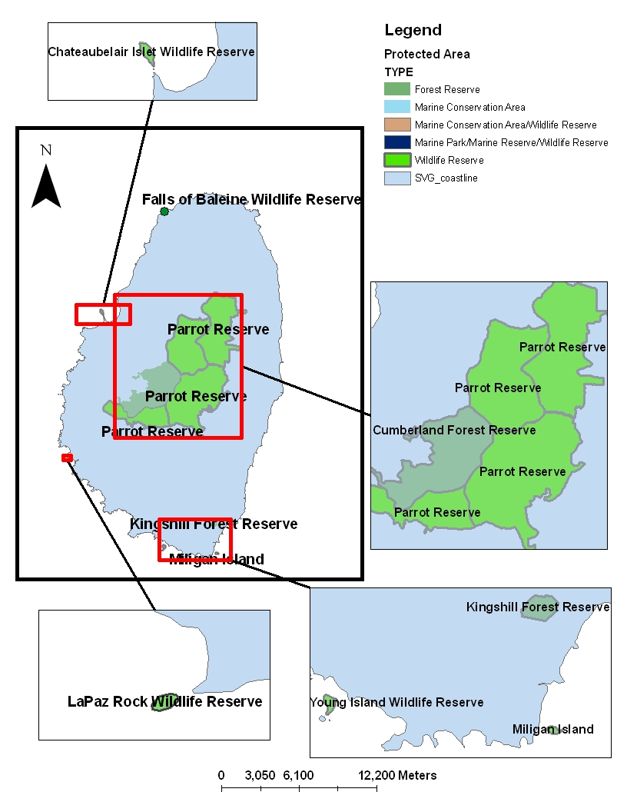
Northern Grenadines
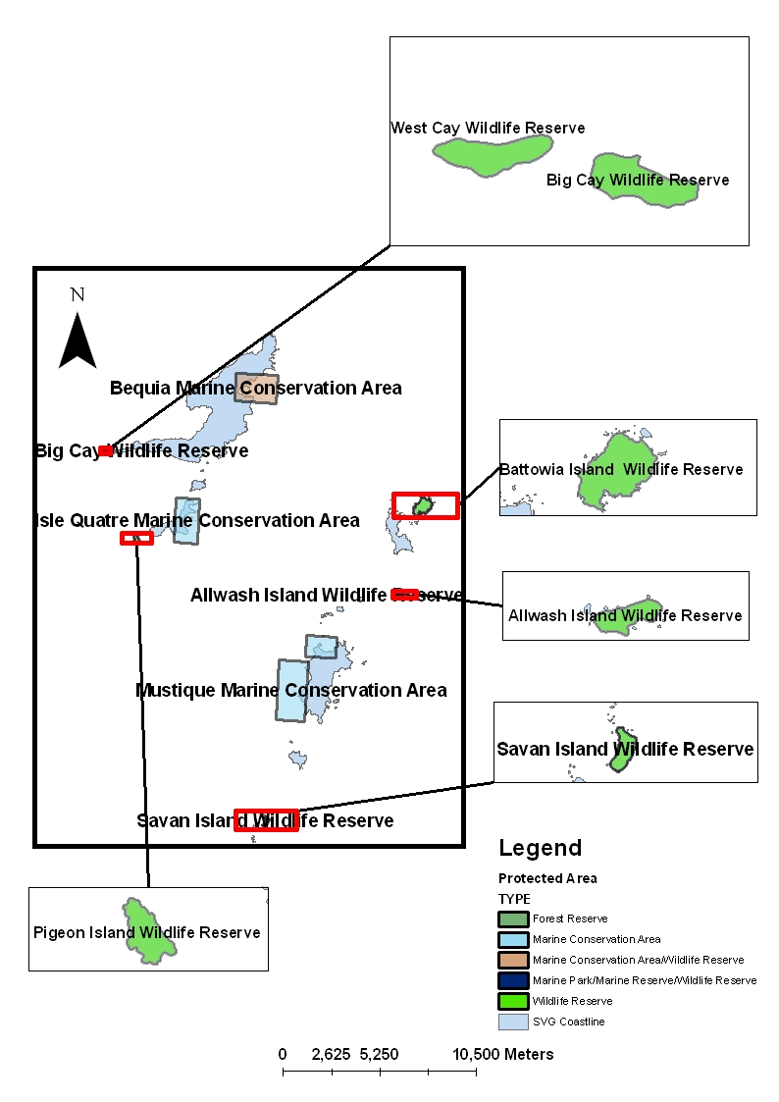

Southern Grenadines
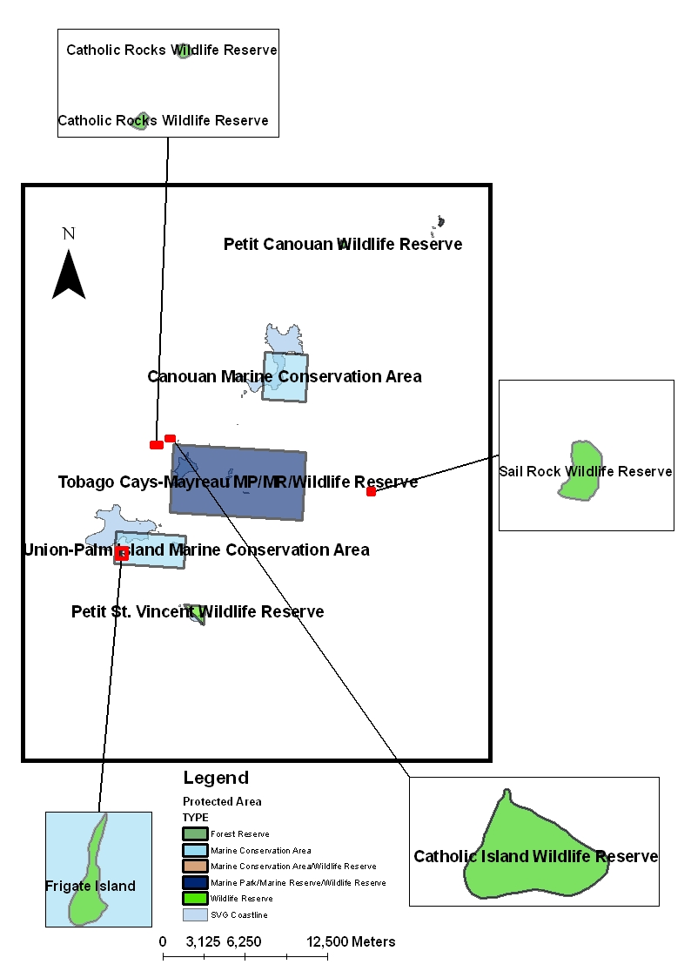

2.2 Proposed Sites

Jackson (2004) suggested that the sites within the system required streamlining. This was to be done by consolidation of very small protected areas into larger units that would have an increased profile and management status thereby increasing its probability for successful implementation and management. He also recommended that steps be taken to eliminate conflicting multiple designations and prevent duplication in management authority and therefore enhance management efficiency. His recommendations were also informed by previous work including the development of the National Biodiversity Strategy and Action Plan.

As such thirteen (13) protected areas were recommended for declassification or re-designation to remove duplication in geographic area designation or to change area management objectives where it was considered appropriate.

Table 2.2: Recommended Sites for the SVG SPA (Jackson, 2004)

Management Category | Status |  |  | Total
 | Existing | Status Change | Proposed
Terrestrial
National Park | ---- | ---- | 1 | 1
Forest Reserves | 3 | 1 | 6 | 8
Natural Landmark | ---- | ---- | 4 | 4
Cultural Landmark | ---- | ---- | 6 | 6
Wildlife Reserves | 24 | 7 | ---- | 17
Protected Landscape/seascape | ---- | ---- | 1 | 1
Marine
Marine Parks | 1 | ---- | 4 | 5
Marine Reserves | 1 | 1 | 3 | 3
Marine Conservation Area | 6 | 4 | ---- | 3
Total | 36 | 13 | 26 | 48

Proposed declassified or re-designated sites are:

  - Forest Reserves: Tobago Cays would no longer be listed as a Forest Reserve but would retain its designation as a marine park.

  - Wildlife Reserves: Seven sites would have changed status:
    - The St. Vincent Parrot Wildlife Reserve to be incorporated into several Forest Reserves
    - Falls of Baleine Wildlife Reserve into a Natural Landmark
    - Chateaubelair Islet Wildlife Reserve as part of the Chateaubelair Islet Marine Park
    - Young Island Wildlife Reserve as a wildlife zone in the South Coast Marine Park
    - Tobago Cays would no longer be listed as a Wildlife Reserve
    - Kingshill Wildlife Reserve would no longer be listed as a Wildlife Reserve but would retain its listing as a Forest Reserve.
    - The Botanic Garden Wildlife Reserve would become a Natural Landmark

  - Marine Reserves: Tobago Cays would no longer be listed as a Marine Reserve. Objectives set under this management category can be achieved through zoning of the Tobago Cays Marine Park.

  - Marine Conservation Areas: Three (3) sites would have a change in status to Marine Reserves:
    - Isle de Quatre
    - Mustique Island
    - Canouan

The resultant system proposed by Jackson (2004) would be comprised of a total of 48 protected areas, of which 22 are existing sites and 26 are proposed. The sites were proposed because of unique or special ecological, biodiversity, historical, cultural, recreational, tourism or aesthetic attributes that exist. The reader is referred to Jackson (2004) for the detailed rationale for the inclusion of each of these sites.

The Jackson (2004) report also led to the development of the European Union funded Tourism Development Programme (TDP) now being implemented. The TDP proposes to develop 14 sites and assist with the development of the Tobago Cays Marine Park by the end of 2009. These sites are listed below:

- Falls of Baleine
- Dark View Falls
- Vermont Nature Trail
- Cumberland Nature Trail
- Layou Petroglyph
- Botanic Gardens
- Wallilabou Falls
- Cumberland Beach Recreation Centre
- Owia Salt Pond
- Youroumei Heritage Village
- Soufriere Cross Country Trail
- Black Point Tunnel
- Rawacou Beach
- Belmont Lookout
- Tobago Cays Marine Park

Another significant piece of work was completed in 2007 by the National Implementation Support Partnership (NISP) for SVG. The NISP Committee is composed of Ministry of Agriculture, Forestry and Fisheries, Ministry of Health and the Environment, Ministry of Tourism, The Nature Conservancy, Centre for Resources Management and Environmental Studies (CERMES-UWI) and RARE. A series of workshops to complete a National Protected Areas Gap Analysis were held by the NISP.

This Gap Analysis is one of the early actions under the Global Protected Areas Program of Work (POW) developed under the Convention on Biological Diversity and agreed to at the 7th Conference of the Parties (COP7). The objective of this analysis was to understand how well the current system of protected areas represents St. Vincent and the Grenadines biodiversity and what actions could be taken to ensure good representation of that biodiversity. The method used for the Gap Analysis followed the official guide put forward by the Convention on Biological Diversity to conduct gap assessments of protected area systems (Dudley and Parish, 2005).

The final portfolio of sites selected by the working group included the existing protected areas, the creation of two protected areas management units for the Grenadines (Northern Grenadines and Southern Grenadines), extension of existing reserves in Fenton, Vermont, Cumberland Watershed and Owia & Fancy and a Leeward Coast Management Area which was proposed by Jackson (2004). The implementation of these sites would only result when the resources are secured. As priority the areas designated already by Law should be focussed on.

Taking into consideration all the opinions and studies done over the years, a total of 75 sites have been proposed that would comprise the SVG National Parks and Protected Areas System and are listed in Table 2.3 below. These sites are not by any means exclusive. Any other site may be proposed in writing to the NPA at any time, upon which a technical analysis would be carried out for the NPA Board’s consideration.

Table 2.3 Protected Areas in the proposed System for SVG.
Protected Area Designation | Protected Area Name
National Park | - Soufriere National Park
Forest Reserves | - Campden Park Forest Reserve  - Colonarie Forest Reserve  - Cumberland Forest Reserve  - Dalaway Forest Reserve  - Kings Hill Forest Reserve  - Kingstown Forest Reserve  - Mt. Pleasant Forest Reserve  - Richmond Forest Reserve
Wildlife Reserves | - All Awash Island Wildlife Reserve  - Battowia Island Wildlife Reserve  - Big Cay Wildlife Reserve  - Catholic Island Wildlife Reserve  - Catholic Rock Wildlife Reserve  - Frigate Island Wildlife Reserve  - Isle de Quatre Wildlife Reserve  - Lapaz Rock Wildlife Reserve  - Milligan Cay Wildlife Reserve  - Northern Bequia Wildlife Reserve  - Palm Island Wildlife Reserve  - Petit Canouan Wildlife Reserve  - Petit St. Vincent Wildlife Reserve  - Pigeon Island Wildlife Reserve  - Sail Rock Wildlife Reserve  - Savan Island Wildlife Reserve  - West Cay Wildlife Reserve

Protected Area Designation | Protected Area Name
Cultural Landmarks | - Layou Petroglyph  - Black Point Tunnel  - Fort Charlotte Peninsula  - Fort Murray, Union Island  - Balliceaux  - Fitzhughes Heritage Center  - Youroumei Heritage Village  - Peter’s Hope Estate  - The Casson House  - Cobblestone Inn  - Montague House  - Bishop’s Court  - Gonsalves Building  - Police Headquarters  - Botanic Gardens  - HM Prison, Kingstown  - Court House, Kingstown  - Carnegie Building  - Blue Caribbean Building  - Government House  - Jacob’s Galleried House  - Frangipani Hotel, Bequia  - Lime Kiln, Bequia  - Spring Estate, Bequia  - Cotton House, Mustique
Natural Landmarks | - Trinity Falls  - Dark View Falls  - The Botanic Gardens  - Falls of Baleine  - Vermont Nature Trail  - Cumberland Nature Trail
Recreational Areas | - Wallilabou Falls  - Cumberland Beach Recreation Center  - Owia Salt Pond  - Rabacca River Recreation Park  - Rawacou Beach
Marine Park | - Tobago Cays Marine Park  - South Coast Marine Park  - Chateaubelair Islet Marine Park  - Petit Byahaut Marine Park  - Anchor Reef Marine Park
Marine Reserve | - Canouan Marine Reserve  - Isle de Quatre Marine Reserve  - Mustique Marine Reserve
Marine Conservation Areas | - Bequia Marine Conservation Area  - Petit St. Vincent Marine Conservation Area  - Union Island/Palm Island Marine Conservation Area
Protected Landscape/Seascape | - Mustique Island  - Belmont Lookout

Figure 2.2: Map of proposed sites.

Northern St. Vincent
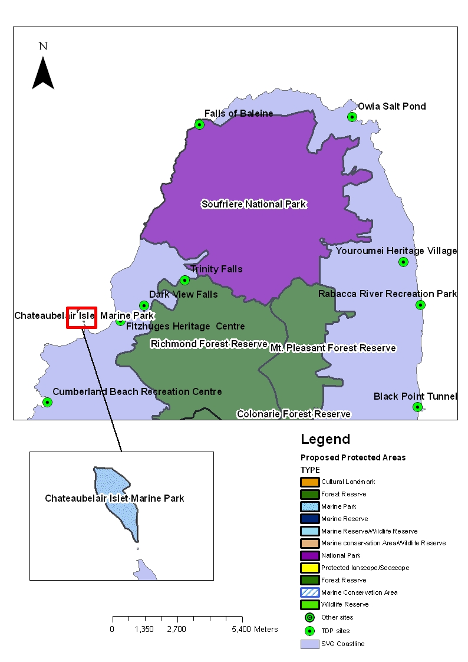
Southern St. Vincent
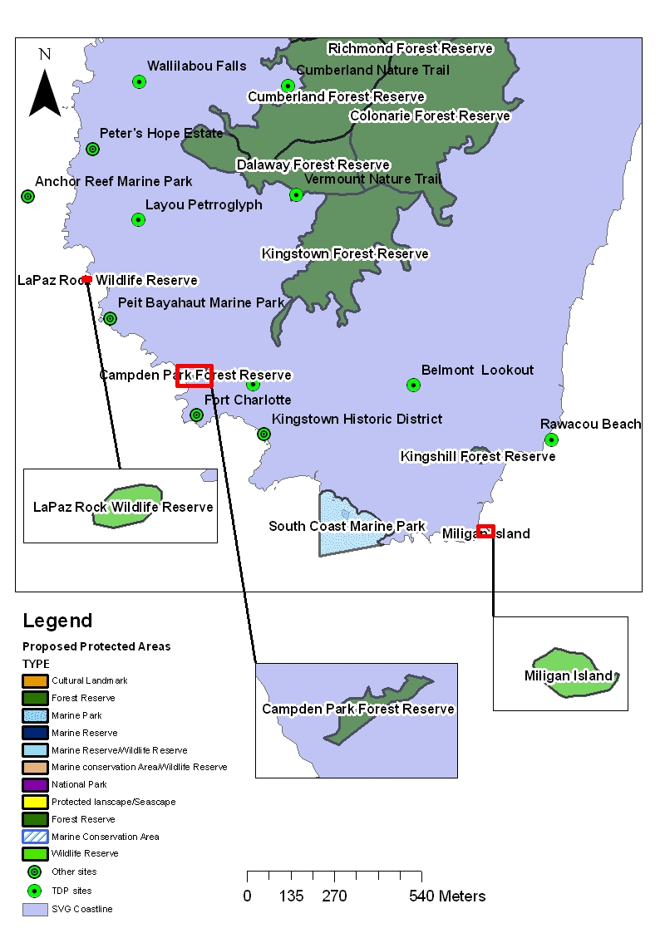

Northern Grenadines
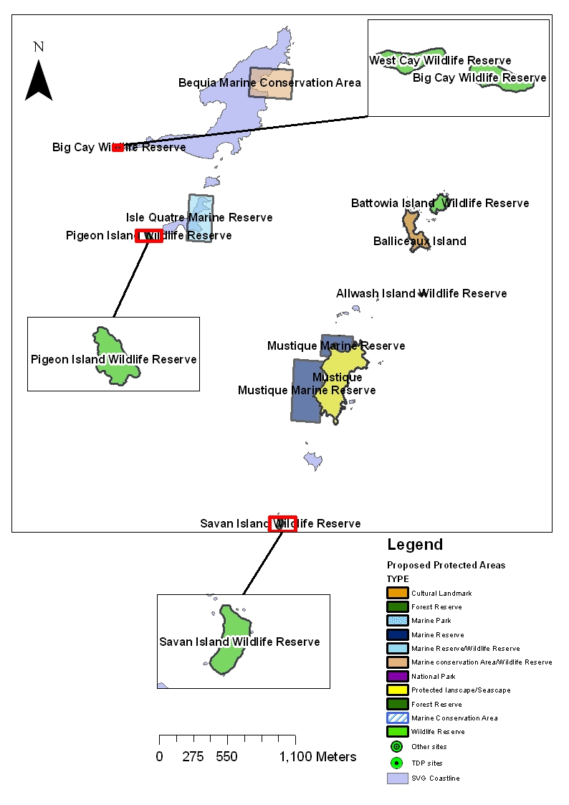

Southern Grenadines
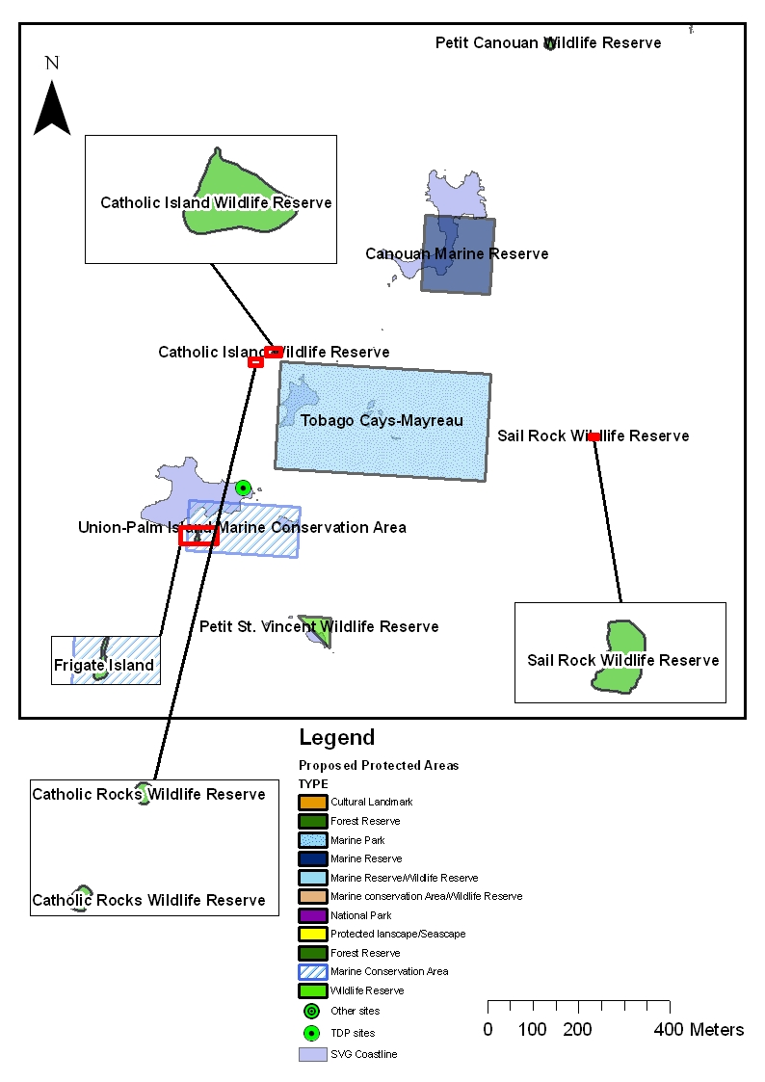

  - International Designation

It is important that the sites in the SVG Parks and Protected Areas System be linked with international designations. This would allow for the sites and the System to receive international recognition and support. It also sets international benchmarks and assures quality for each of the managed areas. International designation is not intended to replace national designations but to assist in communication of the nature of the protected area and its management to an international audience.

One such international designation was developed by the IUCN about 20 years ago as a preliminary system based on protected area management categories. In the late 1980s and early 1990s, the IUCN Commission on National Parks and Protected Areas (now known as the World Commission on Protected Areas - WCPA), reviewed the preliminary system. The IVth World Parks Congress in Caracas confirmed a number of changes, and the IUCN General Assembly approved them in 1994 (Table 2.4).

Using the IUCN classification the proposed protected areas for SVG would receive the international designations listed in Table 2.5.
Table 2.4: IUCN protected areas management categories.

CATEGORY Ia: | Strict Nature Reserve: protected area managed mainly for science
Definition | Area of land and/or sea possessing some outstanding or representative ecosystems, geological or physiological features and/or species, available primarily for scientific research and/or environmental monitoring.
CATEGORY Ib | Wilderness Area: protected area managed mainly for wilderness protection
Definition | Large area of unmodified or slightly modified land, and/or sea, retaining its natural character and influence, without permanent or significant habitation, which is protected and managed so as to preserve its natural condition.
CATEGORY II | National Park: protected area managed mainly for ecosystem protection and recreation
Definition | Natural area of land and/or sea, designated to:  (a) protect the ecological integrity of one or more ecosystems for present and future generations,  (b) exclude exploitation or occupation inimical to the purposes of designation of the area, and  (c) provide a foundation for spiritual, scientific, educational, recreational and visitor opportunities, all of which must be environmentally and culturally compatible.
CATEGORY III | Natural Monument: protected area managed mainly for conservation of specific natural features
Definition | Area containing one, or more, specific natural or natural/cultural feature which is of outstanding or unique value because of its inherent rarity, representative or aesthetic qualities or cultural significance.
CATEGORY IV | Habitat/Species Management Area: protected area managed mainly for conservation through management intervention
Definition | Area of land and/or sea subject to active intervention for management purposes so as to ensure the maintenance of habitats and/or to meet the requirements of specific species.
CATEGORY V | Protected Landscape/Seascape: protected area managed mainly for landscape/seascape conservation and recreation
Definition | Area of land, with coast and sea as appropriate, where the interaction of people and nature over time has produced an area of distinct character with significant aesthetic, ecological and/or cultural value, and often with high biological diversity. Safeguarding the integrity of this traditional interaction is vital to the protection, maintenance and evolution of such an area.
CATEGORY VI | Managed Resource Protected Area: protected area managed mainly for the sustainable use of natural ecosystems
Definition | Area containing predominantly unmodified natural systems, managed to ensure long term protection and maintenance of biological diversity, while providing at the same time a sustainable flow of natural products and services to meet community needs.

Table 2.5 IUCN classification of the proposed protected areas for SVG.
Protected Area Designation | Protected Area Name | IUCN Classification
National Park | - Soufriere National Park | II
Forest Reserves | - Campden Park Forest Reserve  - Colonarie Forest Reserve  - Cumberland Forest Reserve  - Dalaway Forest Reserve  - Kings Hill Forest Reserve  - Kingstown Forest Reserve  - Mt. Pleasant Forest Reserve  - Richmond Forest Reserve | IV
Wildlife Reserves | - All Awash Island Wildlife Reserve  - Battowia Island Wildlife Reserve  - Big Cay Wildlife Reserve  - Catholic Island Wildlife Reserve  - Catholic Rock Wildlife Reserve  - Frigate Island Wildlife Reserve  - Isle de Quatre Wildlife Reserve  - Lapaz Rock Wildlife Reserve  - Milligan Cay Wildlife Reserve  - Northern Bequia Wildlife Reserve  - Palm Island Wildlife Reserve  - Petit Canouan Wildlife Reserve  - Petit St. Vincent Wildlife Reserve  - Pigeon Island Wildlife Reserve  - Sail Rock Wildlife Reserve  - Savan Island Wildlife Reserve  - West Cay Wildlife Reserve | IV
Cultural Landmarks | - Layou Petroglyph  - Black Point Tunnel  - Fort Charlotte Peninsula  - Fort Murray, Union Island  - Balliceaux  - Fitzhughes Heritage Center  - Youroumei Heritage Village  - Peter’s Hope Estate  - The Casson House  - Cobblestone Inn  - Montague House  - Bishop’s Court  - Gonsalves Building  - Police Headquarters  - Botanic Gardens  - HM Prison, Kingstown  - Court House, Kingstown  - Carnegie Building  - Blue Caribbean Building  - Government House  - Jacob’s Galleried House  - Frangipani Hotel, Bequia  - Lime Kiln, Bequia  - Spring Estate, Bequia  - Cotton House, Mustique | III
Natural Landmarks | - Trinity Falls  - Dark View Falls  - The Botanic Gardens  - Falls of Baleine  - Vermont Nature Trail  - Cumberland Nature Trail | III
Protected Area Designation | Protected Area Name | IUCN Classification
Recreational Areas | - Wallilabou Falls  - Cumberland Beach Recreation Center  - Owia Salt Pond  - Rabacca River Recreation Park  - Rawacou Beach | V
Marine Park | - Tobago Cays Marine Park  - South Coast Marine Park  - Chateaubelair Islet Marine Park  - Petit Byahaut Marine Park  - Anchor Reef Marine Park | II
Marine Reserve | - Canouan Marine Reserve  - Isle de Quatre Marine Reserve  - Mustique Marine Reserve | IV
Marine Conservation Areas | - Bequia Marine Conservation Area  - Petit St. Vincent Marine Conservation Area  - Union Island/Palm Island Marine Conservation Area | VI
Protected Landscape/Seascape | - Mustique Island  - Belmont Lookout | V

2.4 Declaration and development of the sites

An area must be legally declared or established by statute to achieve protected status. Of the protected area categories listed above, only national parks, forest reserves, wildlife reserves, marine reserves are recognized in law. Cultural Landmarks and Natural Landmarks are proposed designations requiring amendments to the National Parks Act to take effect. The term Marine Conservation area although widely used by the Fisheries Division in publications and public awareness campaigns is not prescribed by law. Regulations being written for the National Parks Act 2002 will address these issues. Once the Regulations are in place then sites already in existence will be Gazetted under the National Parks Act 2002.

To prevent the creation of “paper parks” it is recommended that the management arrangements (i.e. management plan, financing, institutions, infrastructure, etc.) be established before protected areas are legally declared.

Any new sites being proposed for inclusion in the System would be considered and approved by the NPA after careful analysis and stakeholder consultations. The NPA would then recommend its Declaration to the relevant Minister. Analysis of sites for inclusion in the System would take into account the rationale for inclusion, land use, unique or special ecological, biodiversity, historical, cultural, recreational, tourism or aesthetic attributes, viability, infrastructure, and community support.

Similarly, regular assessment of legally declared sites to improve management should also detect when the reasons for having a protected area are redundant. The National Parks Authority should after careful analysis de-list or re-classify the designation of the sites.

Last but not least, the growth of the SVG protected areas system should be tempered by the financial resources at hand. This is to ensure that the protected areas declared are affordable, viable and sustainable.

- Legal and Institutional Arrangements

3.1 Legislation

The major pieces of legislation governing parks and protected areas in SVG are as follows:

The National Parks Act

In 2002 the Government of SVG passed into law comprehensive Protected Areas legislation, the National Parks Act. The Act created the National Parks Rivers and Beaches Authority and clearly indicates its powers and functions. The Act gives the responsibility of management of the SVG parks and protected areas system to the Authority.

It requires the Authority to see to the development of the parks and protected areas system. The responsibilities may be grouped under the following headings:

- National Parks System Development
  - National Parks Policy
  - National Parks and Protected Areas Systems Plan
  - Declaration of National Parks and Protected Areas
  - Management Plans for National Parks and Protected Areas
  - Management and Operations of National Parks and Protected Areas
  - Systems Development
    - Training and Technical Assistance
    - Standard Operating Procedures
    - Monitoring and Evaluation of the System
    - Research & Development
- Promotion (marketing and public awareness)
- Financing
- Rivers (watersheds)
- Beaches (recreation)
- Laws, Regulations and Enforcement

At present there are no Regulations for this Act. The Regulations are necessary for management arrangements to be based in Law (e.g. management plans, delegation instruments, concessions and concession fees, etc.). The Tourism Development Project Have drafted these Regulations.

A twelve member Board has been appointed for the Authority, staff are being recruited and trained, and initiatives are being undertaken to develop the System of Protected Areas. These efforts are being supported by the Tourism Development Project.

The National Parks, Rivers and Beaches Authority will seek to develop and manage the protected areas system for the country with other government, non-government and private sector stakeholders. The Authority proposes that day-to-day management of protected areas be undertaken by the other stakeholders under delegated instruments of power. It will focus on supporting mechanisms including promotion, financing, training, technical assistance, and quality assurance.

The Forest Resource Conservation Act

The Forest Resource Conservation Act promulgated in 1992 authorises the Minister to declare any Crown land to be a forest reserve. This can be for any of four purposes:
(1) the sustained production of timber and water;
(2) the conservation of soils;
(3) public recreation; or
(4) the preservation of flora and fauna.

Within two years after the declaration of a forest reserve the Director of Forestry is required to produce a Forest Management Plan to guide development and other activities in that forest reserve. In addition, under Section 12 the Minister may declare any area in a forest reserve to be a protected area where there shall be no:
(a) harvesting of timber or other forest produce, or
(b) development or exploration except for trails.

The Forest Resource Conservation Act also permits the Minister to enter into agreements with the owners of private land to declare such land a cooperative forest for any of four purposes:
(1) managing forest plantation or natural forest for the production of timber;
(2) soil and water conservation;
(3) plant and wildlife conservation; and
(4) public recreation.

The Act also allows the Minister (after consultation with the Planning Board) to declare any area of land, whether private, Crown or both to be a conservation area. This can be done for a variety of reasons including:
(1) that the area requires the implementation of conservation practice and management controls;
(2) that the water resources of the area are in a polluted condition;
(3) the area is in a dangerous or unstable state above roadsides or along river and stream banks.

There are no Regulations written for this Act.

The Wildlife Protection Act

Wildlife Protection Act of 1987, (section 16) provides authority to establish bird sanctuaries; by proclamation Young's Island, King's Hill, Government House Grounds including the Botanical Gardens, Milligan Cay, Pigeon (Ramier) Island, and Isle de Quatre have been declared bird sanctuaries. Other wildlife are not covered and no provisions exist to define the management needs of such areas.

Section 16 of the Act also establishes a system of Wildlife Reserves as well as machinery for the creation of further Reserves. By Section 9 (1), the areas defined in the first schedule to the Act are declared as Wildlife Reserves. The schedule includes eight areas in St. Vincent and sixteen areas in the Grenadines.

The largest and most important of these is the 7,596 acres (3075 ha) St. Vincent Parrot Reserve, straddles the central mountain range in St. Vincent, and is intended to afford protection to the endangered St. Vincent Parrot (Amazona guildingii). Apart from the St. Vincent Parrot Reserve, the protected areas in St. Vincent include the King's Hill Forest Reserve, an undefined area in the vicinity of the Falls of Baleine, the Botanical Garden and adjacent grounds of Government House and four shore islands, the largest of which are Chateaubelair Islet and Young Island, off the northwestern and southern coast respectively. Young Island, which is also part of a marine conservation areas protected under the Fisheries Act, 1986, is an exclusive tourist resort.

With the exception of an undefined area at the north-eastern extremity of Bequia, all the Wildlife Reserves in the Grenadines extend protection over the entire area of seventeen small islands, island groups and rocks. Two of these, Petit St. Vincent and Prune (Palm) Island are exclusive tourist resorts. The islands of the Tobago Cays, which are part of a Marine Conservation Area, is protected under the Fisheries Act, and protected as Forest Reserves under the Forest Resource Conservation Act 1992, are also designated Wildlife Reserves under this legislation.

There are no Regulations written for this Act.

Marine Parks Act

The Marine Parks Act establishes a Board of Management known as the Marine Parks Board. This Board has several functions among them things that are done under the Fisheries Act. The original intent under this Act was the formation of a Marine Parks Authority. There has been a Cabinet decision to delay the formation of the Marine Parks Authority as there is potential for legislative conflict with the National Parks Act and the National Parks Authority. The Tourism Development Project in writing the Regulations for the National Parks Act will take into consideration the potential for conflict and present to Cabinet recommendations to streamline the legislation. It seems illogical to have two entities to preside over marine protected areas and the other for terrestrial protected areas. Not to mention the associated costs of funding two administrative mechanisms. This potential for conflict is being dealt with by a robust coordination mechanism as well as the decision to place on hold the creation of a Marine Parks Authority.

Since its formation the Marine Parks Board has focussed exclusively on the management of Tobago Cays Marine Park, a job which it has done well. It is recommended that the Marine Parks Board retain this focus of day-to-day management of marine protected areas but have the National Parks Authority to focus on the management of the System of Protected Areas, which would involve among other things support to institutions responsible for day-to-day management of all protected areas. These ideas are further developed in Chapter 4.

Fisheries Act

The Fisheries Act (No. 8 of 1986), established for the first time a legal framework for fisheries management in St. Vincent and the Grenadines. The Act covers fisheries access agreements, foreign fishing licenses, fish processing establishments, fisheries research and the registration of fishing vessels. The Act also prohibits the use of any explosive, poison or other noxious substance for the purpose of killing, stunning, disabling or catching fish. It empowers the Minister to set up marine reserves for the conservation of the environment and the enhancement of fisheries and to promulgate regulations for prohibiting harmful fishing methods. The Minister may declare any area of the fishery waters (i.e., the waters of the Exclusive Economic Zone EEZ, territorial sea, archipelagic waters, and internal waters as defined in the Maritime Areas Act), and any adjacent or surrounding land, to be a marine reserve.

The Fisheries Regulations (SRO No. 1 of 1987) pertain to the establishment of a Fisheries Advisory Committee and include provisions for foreign fishing vessels, local fishing licences and fish aggregating devices. The regulations also set out fishery conservation measures, such as closed seasons and gear restrictions, and specify coordinates for the boundaries of ten marine conservation areas. Enforcement of the law regarding fisheries and marine conservation areas is the responsibility of any authorised officer (i.e., any fisheries officer, any customs officer or police officer, or any other person designated by the Minister).

The Central Water and Sewerage Authority Act

The Central Water and Sewerage Authority Act, 1992 (section 21) authorises the Minister to set aside protected areas for the protection of water resources related to water supply needs. The Minister may where he considers it necessary regulates activities within such an area.

Cultural Resources

Limited legislative provisions exist in relation to cultural resources that are relevant to biodiversity. Some provisions in planning law protect areas of historical and cultural importance; a local nongovernment organisation, The SVG National Trust, dedicated to the preservation of historical sites has received statutory recognition. There is provision on the protection of aspects of intellectual property.

The Saint Vincent and the Grenadines National Trust Act, Cap. 329 outlined that body’s purpose as the conservation of the historical and natural heritage of St. Vincent and the Grenadines, defined in an early publication on the Trust to include historic buildings, pre-historic sites and Stone Age relics, areas of special beauty and interest with their associated flora and fauna, the reefs, shorelines and small islets of the country. The enabling legislation empowers the Trust to identify, document and preserve buildings, monuments and places of historic and architectural interest, including the acquisition of property and the raising of funds for the management of such property. Executive authority for the administration of the Trust is vested in a Board of Trustees which is elected at an annual general meeting.

The SVG National Trust Act is in the process of being reviewed with a view to expanding the Trust’s mandate. Section 4 (g) (which states “to educate the public in the historical assets and natural amenities of Saint Vincent and the Grenadines”) should be done in collaboration with the NPA and other institutions. The Trust is involved in the preservation of archaeological sites, the upkeep care and protection of cultural assets, island wildlife reserves, museums, and the upkeep of other historic buildings. The Trust keeps a list of the historic and archaeological sites (National Register of Archaeological Sites), buildings and assets, and natural history.

Antiquities now receive very limited protection. Under the statutory regime, The Preservation of Historic Buildings and Antiquities Act, Cap. 247 the Minister of Tourism is empowered to prepare a list of historic buildings. A listed building can not be demolished, altered or extended without the permission of the Planning Authority (Physical Planning Board).

Preservation of Historic Buildings and Antiquities Act, Cap. 247

Under the Preservation of Historic Buildings and Antiquities Act, the government may acquire any building to be a historic building either by agreement or in accordance with the provisions of the Land Acquisition Act.

Section 4 requires the responsible Minister (i.e. the Act indicates the Minister of Tourism) to compile and maintain a list of historic buildings. Once a building is a listed building no development work can be carried out without the grant of planning permission under the Town and Country Planning Act.

Mustique Company Limited Act

Mustique Company Limited Act, 1989 declares the island of Mustique to be a conservation area and directs that appropriate action be taken to conserve and enhance the natural beauty and environment of the Mustique Conservation Area.

Mustique Conservation Act, 2002
Under the Mustique Conservation Act the entire island of Mustique, including its marine environment, is designated a conservation area.

Under the Mustique Company Act all commercial operations on Mustique will be inspected by an authorised person to ensure that no gaseous pollutants, petroleum waste or other residue are discharged onto or into the land. In addition noise pollution from domestic, recreational or commercial operations will be dealt with under the Noise Control Act, 1988.

Any damage or pollution arising out of any commercial operations will be rectified to the satisfaction of the Mustique Company by the operations.
3.2 International Conventions and Agreements

International law is much different from domestic law. Domestic law describes the rights and obligations of persons and the relationship to each other and the government. Domestic legal systems almost always include general methods for enforcing laws and adjudicating disputes.

International laws set out the powers and obligations of nations. Usually only nations, not individuals, may seek enforcement of the laws. Though there is an International Court of Justice, unlike a domestic court, it has no authority to force parties to appear before it or to abide by its decisions. Often international law is established through mutual agreements or treaties, and individual treaties may spell out specific means of enforcement or resolution of disputes. These dispute resolution mechanisms may be open only to countries that are party to the agreement and not to their citizens in their own right.

Some of the key international agreements applicable to national parks and protected areas are discussed below.

The Convention on Biological Diversity

Threats to biological diversity have increased almost everywhere in the world during recent decades, mainly as a result of the destruction of natural habitats. Requirements for the conservation of biodiversity have therefore developed far beyond what was envisaged when the first conservation conventions were concluded.

The Convention’s objectives are to help conserve biological diversity, to promote sustainable use of its elements; and to ensure fair participation in the benefits that may derive from utilization of genetic resources. The agreement sets out an international consensus on these issues and thereby creates a legal framework that will contribute to the preservation of biological diversity.

The Convention requires each signing State to formulate management plans and national strategies for the conservation and sustainable use of biological diversity or to adapt the existing strategies for this same purpose, and integrate the conservation and sustainable use of biological diversity into relevant sectoral or cross-sectoral plans, programs, and policies.

As part of a global approach to conservation, the Convention on Biological Diversity accordingly places far greater emphasis upon the conservation of ecosystems than upon the protection of species as such. Under Article 6 dealing with the in-situ Conservation, parties are required, as far as possible and as appropriate, to: establish a system of protected areas or areas where special measures need to be taken to conserve biological diversity; develop, where necessary, guidelines for the selection, establishment and management of protected areas and areas where special measures need to be taken to conserve biological diversity; promote the protection of ecosystems, natural habitats and the maintenance of viable populations of species in their natural surroundings; promote environmentally sound and sustainable development in areas adjacent to protected areas with a view to furthering protection of these areas; and rehabilitate and restore degraded ecosystems and promote the recovery of threatened species, inter alia, through the development and implementation of plans or other management strategies.

Climate Change Convention

The main objective of this Convention is to stabilize the level of greenhouse gases in the atmosphere, to avoid triggering rapid climate change. One of the effects of global warming is sea level rise which has great significance for small island states and by extension their protected areas. By signing it each party pledges to work for the reduction of greenhouse gas emissions, the protection of greenhouse gas sinks and reservoirs, and the mitigation of any effects of climate change. Each country has to make national inventories of its emissions of those greenhouse gases not regulated under the Montreal Protocol (which governs chlorofluorocarbons and related chemicals affecting the stratospheric ozone layer).

Kyoto Protocol

The Kyoto Protocol represents the first binding reduction target under the United Nations Framework Convention on Climate Change (UNFCCC). Under the Protocol, developed countries (Annex I Parties) agreed to reduce their emissions of greenhouse gases (GHGs) by at least 5% below 1990 levels (Art. 3.2). Individually, each Annex I Party agreed to a specific reduction target to achieve to overall goal.

The Protocol includes a number of flexibility mechanisms that are intended to provide alternatives to domestic emission reductions. These mechanisms include emissions trading (Arts. 4 and 17) (either on a case by case basis or by creating an emission bubble, such as the European Union) and joint implementation of emissions reductions between Annex I Parties and economies in transition (Art. 6). They also include clean development mechanisms (Art. 12), which allows Annex I countries to work with non-Annex I Parties to achieve credits in non-Annex I countries and use the reductions to offset emission in the participating Annex I country.

Finally, the Protocol provides an opportunity to offset emissions beyond the country specific target by removing green house gases from the atmosphere through sinks (Arts. 3.3. and 3.43). Possible sinks include forests, oceans and soils. The details on how these flexibility mechanisms will operate have yet to be worked out.

Convention on Wetlands of International Importance Especially as Waterfowl Habitat, Ramsar, 1971 (Ramsar Convention)

Ramsar, which has been in force since 1975, aims to stem the progressive encroachment on and loss of wetlands, now and in the future. While Ramsar focuses on wetlands that are important for migratory waterfowl, it recognizes the overall value of wetlands, including their fundamental ecological functions and their economic, cultural, scientific and recreational value. Ramsar defines wetlands broadly to include freshwater, brackish and saltwater marshes, including marine waters up to six meters deep at low tide, and any deeper marine waters contained within the wetland area, as well as adjacent islands and coastal areas.
Ramsar parties are to designate at least one national wetland of international importance when signing the Convention or when depositing its instrument of ratification or accession; many parties have designated more than one. Designation of these areas should be an element of the process of identifying priority components of biodiversity under Article of the Convention (see Part II, Action Item 6). Under Ramsar, parties are also required to establish wetlands nature reserves and cooperate in the exchange of information for wetlands management.

Protocol Concerning Specially Protected Areas and Wildlife in the Wider Caribbean (SPAW Protocol)

The Cartegena Convention was drafted in 1983. This regional convention encourages the establishment of protected areas to conserve rare and fragile ecosystems occupied by vulnerable species, as well as the protection of endangered species and sustainable use of wildlife. While the emphasis is on the marine environment, it does include provision for protection of terrestrial species such as the Saint Vincent and the Grenadines Iguana and Amazona parrots.

St. George’s Declaration

The St. George’s Declaration contains the principles of environmental sustainability for the OECS region. The Declaration thus sets out the broad framework for environmental management for the OECS region. The St. George’s Declaration is structured around 21 principles listed in the Declaration. Principle 13 calls on OECS members to protect cultural and natural heritage. In respect of this Principle it is stated in the St. George’s Declaration of Principles for Environmental Sustainability in the OECS (revised 2006) that “the development and establishment of protected areas and institutions for their management, as well as measures for the protection of important heritage sites, species, and green spaces are key elements of environmental management”. Principle 13 also calls on parties to the St. George’s Declaration to protect and conserve biological diversity.

3.3 Institutions

The major institutions involved with the protected areas system are:

- National Parks Rivers and Beaches Authority
- Forestry Department
- Fisheries Division
- SVG National Trust
- Marine Parks Board
- Ministry of Health & Environment, Environment Services Unit
- Non-Governmental Organisations (NGOs)
- Community Based Organisations (CBOs)
- Private Sector companies

The public sector institutions are determined by statute as listed in Section 3.1 and their functions are determined by the relevant Law. The Environment Unit in the Ministry of Health and Environment is the focal point for environmental international conventions, such as the Convention on Biological Diversity, the Cartagena Convention, the Convention on Specially Protected Areas and Wildlife, and others. They have a special role to play in supporting the growth and development of the protected areas system.

The continued development of NGOs, CBOs and private sector interests in the context of protected areas management make them an integral part of the System. They also have a special role to play in supporting the growth and development of the protected areas system.

Coordination

With so many institutions involved in the SVG Protected Areas System there is a critical need for efficient and effective institutional coordination based upon the principles of collaboration, social participation and partnerships. Coordination between agencies is currently managed on the basis of personal and informal relationships between agency employees rather than through established guidelines or defined roles and responsibilities.

The National Parks Rivers and Beaches Authority is proposing it play this coordination role for all actions within the protected areas, involving and utilizing the different agencies and local groups to capitalize on their specific areas of expertise. Key actors include the Fisheries Division, Forestry Department, Environmental Services Unit, National Parks, Rivers and Beaches Authority, Central Water and Sewage Authority, SVG Coast Guard, and SVG Port Authority.

The Capacity Action Plan done by the NISP indicates that the largest single action required to consolidate the Protected Areas System is to formalize and coordinate inter-institutional arrangements for all involved protected areas management agencies. This would include joint planning sessions between agencies, defining roles and responsibilities, and improved communications between all stakeholders. The outcome of this process will be the development of Memoranda of Understanding (MoU) between the NPA and the other stakeholders. The MoU could result in the stakeholders having joint annual work planning between the agencies, determination of each participants roles/responsibilities within the protected areas, coordination with local entities (both public and private), and a participatory management planning process that involves all.

Partnerships
Government’s policy to involve community NGOs and Community Based Organizations (CBOs) will be advanced through co-management arrangements for heritage sites and selected Cultural or Natural Landmarks where appropriate. These arrangements through Memoranda of Understandings (MoUs) will be made between the NPA and qualified NGOs or CVOs. Chapter 4 will elaborate further on co-management arrangements.

Private sector participation could be achieved through incentives to stimulate enterprise development associated with protected areas and heritage sites and by negotiated concessions to operate in selected sites. Public/private sector partnerships are to be forged in cooperative arrangements required for effective management of important heritage assets. For example, in the case of scuba diving sites dive operators could assist the Fisheries Division and the Marine Park Board in monitoring reef quality and in providing ongoing information on levels of diver activity.

Training

Developing a cadre of protected area personnel in the country with competencies in a range of managerial and technical skills are needed to effectively implement the System. The NPA is gearing up to take on the management of the System of protected areas system management. A thorough staffing assessment will be conducted to determine the current protected areas staffing levels and capacity within the various agencies. This will allow the NPA to determine both its own staffing needs, and need for additional support at the Fisheries Division, Forestry Department, Environmental Services Unit, and any of the other institutions.

Under the OECS Protected Areas and Associated Livelihoods Project (OPAAL), a capacity building assessment was conducted on SVG’s protected areas system. The report detailed recommendations for training needed at the site, system and local community level to improve protected areas management. These results along with the NISP Capacity Development Plan will be used as a starting point for a training needs assessment to determine where and how to provide priority training to existing staff and how trained staff can share lessons learned through training within their agency.

In addition, the NPA Board may require training to guide its work in providing oversight and guidance to the NPA, particularly in protected areas management, decision making processes, roles and responsibilities, and financial oversight.

- Management

The SVG Protected Areas System requires effective management at two levels, at the System level and at the Site level. It is important that the roles and responsibilities be clearly defined throughout the System, which has been outlined in section 3.2 above.

4.1 System Management

It is important that effective System management takes place. The NPA has indicated that this is the primary role that it sees for itself as mandated in the National Parks Act 2002, in particular Sections 7 and 9. System management functions involve the design, development, technical support, monitoring and quality control of the SVG protected areas system as a whole. The elements of System management include those outlined below.

    - Protected Areas Policy

The Board of the NPA is responsible for developing and guiding the Minister on matters of Policy. The Board is guided by the Director in formulating, reviewing and updating the Policy based upon best practices, research, consultations with relevant stakeholders, and feedback from operations of the system.

    - Protected Areas System Plan

The Board of the NPA is responsible for developing the System Plan and for its submission through the Minister of Tourism for Cabinet approval. The System Plan will include national parks and other protected areas including areas of ecological, historical and cultural, and recreational importance. The Director of the NPA and his staff would assume responsibility for drafting the Plan for Board approval.

The System Plan is developed through a series of stakeholder consultations, information from available documentation, and finally through public consultations before submission to the Board. The System Plan will undergo review and update at regular intervals (every 5 years).

    - Protected Areas Declaration

The System Plan will indicate protected areas that are to be declared under SVG Laws, including the National Parks Act 2002. Once the System Plan has been approved by Cabinet, drafting instructions will be developed by the Director and approved by the Board for submission to the Minister such that an Order can be made and gazetted to declare the protected areas under the Act. The Board and the Director may seek to have specific advice from a legal specialist on this matter.

    - Protected Areas Management Plans

Management Plans specific to each protected area will need to be developed. These may be developed by the NPA or by other agencies (Government, NGOs, Community-based Organisations (CBOs), or private sector) that are delegated or are seeking delegation of the management and operations of specific protected areas.

The Board of the NPA must approve each management plan. The Director of the NPA and the Superintendent of Marine and Terrestrial Parks should review each management plan and produce a report with recommendations to the Board for its deliberation. In the case where the NPA develops the management plan the Director and the Superintendent of Marine and Terrestrial Parks are responsible for its production.

    - Training and technical assistance

Technical assistance and training will be delivered to the System through the NPA. The NPA staff will regularly conduct a training needs assessment of all stakeholders and develop an annual training plan to meet the needs for the development of the System for approval by the Board. The training plan will also include the needs of the NPA staff. Training and technical assistance may be out-sourced as well as being delivered by NPA staff.

    - Standard Operating Procedures

The NPA staff will draft standard operating procedures (SOPs) for each protected area based upon the management plans developed for each protected area. The SOPs will be developed with the involvement of stakeholders associated with each protected area. The Director will approve these procedures and inform the Board. These procedures may change from time to time based on periodic review of the management and operation of the site specific areas. The SOPs are intended to support the implementation of the management plan for each protected area and should include monitoring and evaluation mechanisms.

    - Monitoring and Evaluation of the System

The NPA will have responsibility for the monitoring and evaluation of the System. Monitoring will be done through periodic site visits by the NPA staff. A monitoring template will be developed and be used on each site visit and should be filed electronically as well as hard copy by site and date. Evaluations will be done through auditing by the Superintendent of Marine and Terrestrial Parks every six months after operation of the site commences. Monitoring and auditing will be conducted using the approved management plan for each site as a benchmark.

The monitoring and auditing reports should be summarised and submitted to the Board on a quarterly basis to keep them informed as to the state of the System. These reports should be combined into an annual report drafted by the Director and approved by the Board and submitted to the Minister and Cabinet. This annual report, “Status of the SVG Protected Areas System”, should be published and used in marketing, informing stakeholders and users, and donor organisations and individuals.

Chapter 6 focuses in greater detail on the growth of the System by periodically and regularly reviewing, monitoring and evaluating the System and learning from the lessons of implementation and day-to-day management of the SVG protected areas.

    - Research & Development

Research and development is essential for the development of the system of protected areas. Analysis of information and data from the ecological, cultural, historical, financial, marketing, protected areas management, etc. disciplines are essential for the continuous development of the System. Liaison with national, regional and international bodies is essential. The use of Internet research should inform the analysis of data generated at the site level. Actual research and development at each site is necessary but can be costly. These costs may be reduced through cooperative agreements with research institutions and other bodies (e.g. UWI, CERMES, CEHI etc.). Joint research projects with key stakeholders (Forestry, Fisheries, etc.) will also be promoted.

    - Promotion (marketing and public awareness)

Promotion of the NPA, national parks and protected areas as well as conservation messages is important in building national support for the System. An interpretation and public awareness programme is required. The NPA will be drafting and implementing a public education campaign as part of its annual work. Materials produced under this plan can easily be transformed into marketing information. However, it may be cheaper to out source marketing expertise than having the skill in house. The NPA should also look towards coordinating efforts of all the stakeholders involved in protected areas to ensure greater impact.

    - Financing

Financing of the NPA and the System is essential for its sustainable development. The sustainable financing of the System is the responsibility of the Board. Sustainable financing has two components. The first is exercising cost control through the approvals of the Systems and Management Plans for each site such that the resources are targeted and measured for each activity. The annual budget and work programme of the NPA requires Board approval.

The second is the maximisation of revenues (entry fees, concessions, gift shops, charges for services, etc.), donations, government subventions, and other financial mechanisms, such that operating costs are covered at a minimum and profit is made as an ideal. It should be noted that the revenues from each protected area will vary greatly and mechanisms will need to be employed that allow for funds from more ‘profitable’ sites to be used in supporting other less ‘profitable’ sites in the System. The use of Trust Funds and Endowment Funds should be investigated and are highly recommended.

Chapter 5 focuses in greater detail on the strategies to be pursued with regards to the sustainable financing of the SVG protected areas.

    - Rivers (watersheds)

The management of the buffer zone adjacent to the declared protected areas is essential to reduce threats to the protected area. In SVG these areas may include rivers, streams, waterfalls and water pools. The management of rivers associated with protected areas is a responsibility of the NPA designated by the National Parks Act. The integrated watershed management approach is recommended as a way in which to effectively address the environmental issues. Liaison with other national bodies (Planning, Forestry, Fisheries, Environment, Utilities, etc.) is essential. A consultative jointly planned and executed watershed management plan would be useful for managing the riverine resources of SVG. The NPA will be seeking to coordinate the efforts of the major stakeholders in the development of an integrated watershed management plan for those watersheds that influence the integrity of declared protected areas.

    - Beaches (recreation)

The management of recreational sites including beaches declared under the Act is a function of the NPA. The Superintendent of Rivers, Beaches and Recreation will have oversight function for beaches and recreational sites. Therefore, the Supervisor would have the responsibility to ensure that sites would be effectively managed, either directly or indirectly, according to approved management plans to ensure the highest quality of visitor experience. Recreational sites like other declared protected areas could be delegated to a management entity.

Management of these sites should adhere to proper coastal zone management with an emphasis on regulated sand mining. The NPA should encourage a national debate on sand mining with its attendant destruction of the beaches the outcome of which should be a clear policy statement with alternatives and strategies to deal with this destructive practice.

    - Laws, Regulations and Enforcement

Laws, regulations and enforcement are the responsibility of authorised officers under the Act. These authorized officers are the NPA staff and the security forces. The NPA will be making linkages with the security forces and offer training and sensitisation to the importance of enforcing the Act. The development and implementation of this programme will be supported by a public education campaign.

Interpretive enforcement should be the philosophy behind enforcing the Act. In essence this is urging voluntary compliance through public education. However, not everyone will be convinced through awareness so the NPA will prepare itself for the successful prosecution of offenders.

    - MoUs for System Management

The NPA in its efforts to achieve management of the system in a relevant, effective, and cost-effective way will develop and sign MoUs with key stakeholders. The design principles for the MoUs, which will develop a new and modified institutional framework for Protected Areas in SVG include:

- Retention of Responsibilities: Existing organisations will retain their responsibilities and the goal will be to improve their efficiency and deliverability.

- Non-Duplication: there shall be no duplication of responsibilities as this is not cost-effective and frequently results in chronic inaction.

- Capacity Building: organisations with a base, experience and expertise should be strengthened to enhance deliverability and assist other agencies.

- Collaboration and Partnership: to the greatest extent possible there should be a mechanism to foster and enhance institutional collaboration in environmental and resource management.

- Optimum Revenue Generation: every effort must be made to raise funds through various means without compromising environmental integrity for use in the development and management of the protected areas system for SVG.

These design principles should be used not only to design a modified structure, but also to evaluate the performance of that structure over time.

  - Site Management

    - Management and Operations

It is a matter of policy that, wherever possible, the management and day-to-day operations of national parks and protected areas within the System will be delegated to a responsible agency (Government, NGOs, CBOs, private sector – companies with a broad community shareholder representation will be favoured) in order to achieve local, on-site, effective management of designated sites. The NPA would focus on the development of the System (planning, financing, marketing, setting standards and guidelines, providing training and technical assistance, monitoring and evaluation, research and development).

Essentially, as many sites as possible would be managed by NGOs and CBOs, allowing the NPA to concentrate more of its resources in product development and marketing, research and monitoring, training, standards and quality control, and providing oversight to the operations of the NGOs and CBOs. Full delegation is used here to apply to an agreement in which an organization takes responsibility for all day-to-day management functions at the site. Partial delegation refers to an agreement in which an organization is contracted to undertake selected functions. These may include managing an interpretation centre, tour guide services or any combination of services agreed with the NPA.

Partial delegation also means that all management services not assigned to the organization in the MoU would be kept by the NPA. It therefore implies co-management, a term often used to define the relationship between a heritage management authority and community groups. An MoU under this arrangement would set out the terms and conditions of the agreement between the NPA and the organization for the management of a site. These terms and conditions plus the responsibilities of each party would be tied to objectives and management activities set out in the management plan for the site.

The NPA will identify and evaluate entities that may be suitable for delegation. Delegation instruments (contracts, MoUs, etc.) will be developed and form the basis for negotiations and agreement between the NPA and the entity seeking delegation.

Site management functions can be divided into two main areas, namely, direct visitor services and operation and maintenance activities, as listed in the table below.

Table 4.1: Site management functions

SITE MANAGEMENT FUNCTIONS
Direct Visitor Services | Operations and Maintenance Activities
(a) Visitor Centre Activities  - Reception & hospitality  - Ticket & fee collection  - Information services | (a) Staff supervision  - Assigning work details  - Time keeping  - Monitoring compliance with dress code & staff rules
(b) Marketing & sales  - Distribution of brochures  - Responding to inquiries  - Making presentation to groups | (b) Record keeping  - Management of Visitor Register  - Daily tabulation of visitor numbers  - Monthly reports on visitor performance  - Maintaining records of tickets or gate fees
(c) Interpretation Services  - Tour guiding  - Dance, song, shows  - Other media | (c) Monitoring Compliance of Service providers  - Food & beverage vendors  - Craft & gift vendors  - Tour operators  - Independent tour guides
(d) Retail enterprises  - Food & beverages  - Crafts  - Gifts & souvenirs  - Cultural entertainment  - Other | (d) Facilities & Infrastructure Maintenance  - Visitor Centre, toilets, picnic shelters, etc.  - Signs & exhibits  - Paths, trails, drains  - Steps  - Foot bridges
(e) Safety & Security  - Guards  - Lifeguard or life saving services  - Visitor control  - Emergency Procedures | (e) Equipment Maintenance  - Weed cutters, lawn mowers, saws  - Life rings, life vests, etc.  - Boats (if appropriate)
(f) Grounds Maintenance & Facilities Cleaning
- Landscaping
- Litter control
- Garbage collection & disposal
- Cleaning of toilets & other facilities
(g) Research, Conservation, Preservation Efforts
- Support initiatives by key System Management Entities.

    - MoUs for day-to-day site management

The MoUs will need to cover the following areas:

- The development and agreement to a management plan that will determine how the site will be managed.
- The responsibilities of the delegated entity (partial or full delegation).
- The responsibilities of the NPA to provide technical support and training to assist in capacity building of the entity receiving delegation.
- The budget for site operation and the contributions of the delegated entity and the NPA.
- The agreed standards and practices for operating the site.
- The agreed mechanism for quality control (monitoring, auditing) and review of management such that there will be a continuous improvement in the management of the site.
- The revenue generating activities that will take place at each site, the agreed charges for services and the agreed split in income between the NPA and the delegated entity.
- The duration of the Agreement.
- Reporting requirements to the NPA by the delegated entity.

    - Management Plan

Pivotal to the MoU is the agreement of the Management Plan for the site. The management plans should contain all the issues, management objectives, strategies and actions that will result in effective management of the site. The Management Plan should be developed collaboratively with all the major stakeholders and be approved formally by the NPA.

The Management Plan should include, but not limited to, the following:

- Vision and mission for management of the site
- Management Objectives for the site
- Management Structure that will be put in place for site management. This should include positions, number of staff, and responsibilities of staff.
- Visitor services should be identified and described and methods of delivery of service elaborated. Examples of visitor services include (interpretation and information services, visitor traffic management, safety and security, health and hygiene, maintenance, etc.)
- Training requirements should be identified
- Methods of assessing management effectiveness and its use in improving the quality of service and management of the site.

- Financing

Protected areas systems all over the world have struggled to become financially self sustaining. In fact most, if not all, do not have enough funds to sustain themselves. The SVG protected areas system is no different. However, all of them have employed strategies and mechanisms in order to strive to achieve this elusive goal. The development of the SVG protected areas system can learn from the experiences of others. This chapter outlines the concepts and strategies that could be pursued in working towards financial sustainability for the SVG protected areas system.

In 2007, work done by TNC through the SVG NISP has shown that government funding of the SVG protected areas system has been on average about EC$4.1 million per year. This does not adequately meet the needs of the PAS. The current funding gap is estimated to be EC$2.7 million when the cost of managing and operating the system is calculated.

The report emphasized the point that the protection of the environment has continued to be an important part of the government’s agenda and that 25% and 50% of the terrestrial and marine environment respectively have been designated in St Vincent and the Grenadines as protected area.

The creation of a Protected Area Trust Fund and the implementation of a national user fee system were recommended by the report as two of the most viable financial mechanisms to close the financial gap, among others.

The choice of the revenue generation mechanism(s) chosen will be predicated on the cost effectiveness of implementation.

5.1 Financial Mechanisms

This section of the Plan outlines the financial mechanisms that could be utilised to raise the funds required by the SVG protected areas system.

5.1.1 Multilateral Funding

The Global Environment Facility (GEF) is the funding arm of the United Nations Environment and Development Programs and funds activities in four major areas: biodiversity, water, climate change and desertification. Biodiversity programs in SVG have primarily only received funding for the reporting requirements under the CBD. Half of all funding is geared towards Small Island Developing States or Least Developed Countries. This puts SVG in a good position to access this GEF funding and apply it towards implementing new financial mechanisms for the protected areas system.

In the next window, GEF IV, SVG is eligible to receive up to US$3.6 million although it should only expect to be able to access about US$1.0 – US$1.5 million of these funds. This is perhaps the biggest opportunity for the System in terms of multi-lateral funding. Although multi-lateral funding is not a stable, long term funding source it might provide the investment costs for the development of the System.

5.1.2 Bilateral Funding

Bilateral funding for natural resource projects has come primarily from the French, Japanese, and Canadian governments in the past. Currently, there is a European Union funded project, the Tourism Development Project, which is helping to develop the NPA, the protected areas system and 18 designated sites in the amount of EC$20 million over three years. Other bi-lateral sources of funding may be accessed in the future to continue the work started by the project and to expand and grow the protected areas system.

5.1.3 Protected Area User Fee System

The only protected area to charge a fee currently is the TCMP. Compliance is reported to be quite high. This bodes well in terms of introducing a country-wide system. It has been estimated that revenues could be as much as EC$1,325,640 per annum that could be generated from park entrance fees. Entrance fees would attempt to cover the majority of the operational costs at each site. Entrance fees might also contain charges for services at the site.

Although a Willingness to Pay study for the Vermont Nature Trail conducted in 2001 showed that 64% of visitors would pay $US10 or EC$27, it was recommended that an entrance fee between EC$5 and EC$13 be introduced. However there is a possibility then that the fees could increase in the future and raise more revenue. A further willingness to pay study and an ecosystem valuation study will be done in 2009 on the entire protected area system.

There are sites under development that do not have plans to charge entrance fees, for example recreational beach areas or lookout points where it would be difficult to enforce an entrance fee policy. Although at these sites it would still be possible to charge for services (e.g. toilets, beach chairs, fire pits, etc.) and concessions (food, gift shops, etc.). There are administrative costs associated with collecting fees, such as labour and infrastructure costs.

In order to not price the protected areas system out of the range of the ordinary citizen it is proposed that an annual pass be available to residents of SVG. Residents would, for the price of a couple entrance fees, get an annual pass that would allow them to enter all the protected area sites in the country. This would also take into account that the residents would already be paying taxes some of which would go to supporting the protected areas system.

5.1.4 Government Contribution

The government contributes a substantial amount to fund the various departments that are involved with Protected Area management and environmental issues in general. Without this continued input from Government it is unlikely that the system would become financially sustainable. The national parks and protected areas system is a national one and public investment in its growth and operations is required.

5.1.5 Airport Fee

In some countries, for example Belize, a percentage of the departure taxes is used to support the protected areas system. In SVG, the government charges an EC$40 airport exit tax. If the exit tax could be expanded to include a US$1 PA fee, then EC$256,500 per annum could be raised based on the present departure numbers. Since the NPA is a statutory body, they have the power to charge fees to cover their costs so new legislation would not have to be introduced. In addition, the collection system is already in place with the exit tax. An independent fund would have to be created to ensure the money goes to the protected areas system and not into the consolidated fund. The rationale behind such an environmental airport fee is that tourism is dependent on the natural resources found in the protected areas system and increased tourism means greater revenues derived. Increased visitors means more likely impacts on the natural resources so that some of the revenues derived from an increase in numbers should help to pay for the maintenance of the natural resources found in the protected areas system.

5.1.6 Cruise Ship Fee

Cruise ships currently pay an EC$15 per passenger fee. EC$4 of this fee goes to the CWSA and the rest to the consolidated fund. It is possible that cruise ship passengers would be willing to pay an extra US$1 to support the environment that they are enjoying. With 72,000 visitors per year, this could generate EC$194,400. Since cruise ship packages are all inclusive there would need to be negotiations with the cruise ship companies which in the past has proven difficult. The cruise ship industry is extremely competitive and countries are constantly striving to attract more and more cruise lines. SVG’s Port Authority just recently finished a cruise ship terminal with a projected 20 year return on investment. In Belize, the government recently implemented a US$2 per passenger protected areas fee.

5.1.7 Trust Fund

In order to leverage revenue generated and make it sustainable in the long term a protected areas trust fund could be established. A trust fund is a mechanism which has the objective of mitigating the variability of revenue flows from other financial mechanisms to ensure that selected management activities receive stable and continuous funding. The protected areas trust fund would be an independent non-governmental source of funding dedicated to the development, management and operation of the SVG protected areas system.

The Protected Areas Trust Fund will not replace but supplement and reduce the amount of direct Government funding to resource management agencies in the annual estimates of expenditure. It is recommended that a comprehensive design be done prior to establishing such a fund to ensure the correct modality is used, that transparency is ensured and that accountability is assured.

It is recommended that the protected areas trust fund would have an endowment component initially capitalized by a medium sized grant from the GEF. It would also act as a pass through entity for revenue that is generated at the designated sites, multi- and bi-lateral funding, donations, and for Government inputs. If a protected area trust was established and capitalized to have US$3 million in principal, averaged a ten percent annual return and had a five percent annual disbursement amount from the principal, then it could generate EC$445,000 per year.

The possibility of a trust fund being established is high. The GEF IV window is looking to finance projects that implement sustainable financing mechanisms that will fund biodiversity conservation over the long term. It no longer is going to fund protected area management costs directly. Therefore, the incentive is high for governments to set up a transparent and independent mechanism like a protected areas trust fund.

A Board of Trustees would be established which would develop an investment management plan, oversee the financial management of the fund and decide how to distribute the annual disbursement of money from the interest and dividends of the fund guided by the Protected Areas Policy, the National Parks Act, the System Plan, and the Management Plans of each of the designated sites within the protected areas system. This board would consist of individuals from both the public and private sector who work in or know about finance and investment as well as environmental, conservation and protected area issues. The Board would administer the funds in such a way as to meet certain criteria that are in line with the trust’s mission and goals which would be informed by the Protected Areas Policy, the National Parks Act, the System Plan, and the Management Plans of each of the designated sites within the protected areas system.

Transparency and financial reporting would be built into the structure of the trust fund by contracting an independent auditor to review accounting and financial statements. As an independent body from the government, a fund like this becomes more efficient and can respond more quickly and more flexibly to the changing needs of the protected areas system. The trust fund also gives donors more confidence that their money is being directly spent on the protected areas. Donors traditionally have been very supportive of the creation of protected areas trust funds.

5.1.8 Donations

Donations from private individuals and organisations locally and from all over the world are possible (citizens, visitors, Diaspora, companies, foundations, etc.). As the protected areas system is visited and marketed locally and globally support for the SVG protected areas system should grow. Some of this support may be translated into cash, equipment, technical assistance, etc. Funds collected from donations should be channelled into the Trust Fund to maximise returns. To provide incentive for philanthropy donations should be made tax deductible.

The Belize exit charge started out as a voluntary fee. If the exit airport fee or the cruise ship fee could not be implemented then donations could be solicited at the ports of entry in the form of a “pennies for parks” campaign where visitors place their change in a collection box before leaving the country. A major promotional campaign would have to be put in the airport to inform visitors of how their donation would be spent and why it is important to support the protected areas in SVG.

5.1.9 Payment for Environmental Services

Payment for Environmental Services is a financing mechanism which generates revenue by applying a cost to services provided for “free” by nature. Users who benefit from the service pay to ensure that nature continues to provide the service. This is usually at a much lower cost than Man-made substitutions. One such service provided by nature is clean water. St. Vincent is blessed with an abundant source of water which, for now, meets its needs for water demand for both household consumers and businesses such as the bottling plants. The supply of water also goes towards providing seasonal hydro-electricity. Forests are instrumental in enabling watersheds to provide this clean water to the public. In order to ensure continued adequate and reliable supply of water investment must be made in watershed management and forest conservation. They prevent soil erosion and act as filters as well as aiding in the hydrological cycle. Therefore, in order to protect the valuable services provided by watersheds, the forests must also be protected.

The CWSA is responsible for the provision of water supplies, distribution of water, and conservation, and protection of catchment areas. The latter, conservation and protection activities are done in cooperation with the Forestry Department but not enough funding is allocated to this end. Although the CWSA and VINLEC provide some funding to the Forestry Department for its Integrated Forest Management and Development Programme it is not adequate to protect the forests from agricultural exploitation. Agricultural cultivation continues to creep into forested areas that protect watersheds.

A new source of revenue for such protection could come from implementing a conservation surcharge which would be used to protect the forests surrounding watersheds and to manage these important and strategic areas. The important aspect of such a surcharge is that, as water demand increases, the alternatives to supplying water, become more and more expensive, therefore conservation of watersheds is the most cost-efficient way to at least maintain if not increase the supply of clean, fresh water. It is economically prudent to invest in protective management today which also offers other indirect benefits like preserving bio-diversity in the forests, sequestering carbon etc.

One obstacle comes from a user price perception as many people feel that they are already paying too much for water and electricity and there is a general feeling that water is not scarce. Although water is readily accessible to most of the population, electricity is seen as being very expensive. As the cost of fuel rises, hydro-electricity becomes more and more important which means that an abundant supply of water is vital. An extensive public awareness campaign explaining the linkages between water and forests would have to coincide with any surcharge on water consumption to educate people as to the necessity and long term efficiency of such a programme.

- Monitoring and Evaluation

No matter how well the system is designed there will be always room for improvement. Indeed the SVG protected areas system will need to grow and evolve based on changing threats and opportunities which is almost guaranteed to happen. Therefore, a mechanism of gathering data on the performance of the system is required which would be analysed and reviewed periodically. Such an analysis would guide decision making as to the changes in management and operation of SVG protected areas in order to continually improve. In such a way the NPA would influence quality control, setting of standards and building standard operating procedures for all sites within the protected areas system.

The NPA has the responsibility to implement these monitoring and evaluation mechanisms, which are outlined below.

6.1 Performance Evaluation

An objective evaluation of the performance of the SVG protected area system is essential. Performance is measured against the Protected Areas Policy, the System Plan and the Management Plans for each site within the System. Data gathering will be done in three key ways:
- Monitoring
- Auditing
- Customer feedback

These performance evaluation mechanisms will be used to focus the efficient use of scarce resources in order to continually improve the quality of the System.

6.1.1 Monitoring

Monitoring will be done through regular visits by the NPA staff to each site within the Protected Areas System. A monitoring template, check sheet, will be developed by the NPA which would capture and measure management effectiveness as measured against the objectives and targets outlined in the Management Plan for each site. These monitoring reports would be filed for each site and shared with the manager of the site. Any variances in management performance will be discussed with the manager and corrective action agreed upon, this would also be reflected on the check sheet.

Monitoring reports should be summarised each quarter and submitted to the NPA Board for information.

6.1.2 Auditing

Every site in the system should be audited at least once a year. An audit will check that there is proof, a paper trail, that there is conformance with the Protected Areas Policy, System Plan and the Management Plan at each site. Documents including the monitoring check sheets and other documents will be used to measure conformance. Corrective action requests will be issued against any non-conformance found. These requests will be agreed with the management entity. The audit will be conducted by the Superintendent of Marine and Terrestrial Parks or the NPA Director.

6.1.3 Customer feedback

Every site will have a method of recording visitor comments. These will be collected and analysed by the site level managers and the NPA. If a visitor takes the time to comment on the experience they have had at the site it is invaluable feedback that should be taken into account in the improvement of the operations of each site.

6.2 Analysis and Evaluation

On an annual basis an analysis of the monitoring, auditing and customer feedback will be done for each site in the System by the NPA Director. The Director will use these data and analyses to present a report to the NPA Board to evaluate and make decisions with regards to the management of the protected areas system. These reports will be concise, one-page, and will include the following:
- the management objectives and targets
- management conformance with the objectives and targets
- recommendations for corrective action at the site
- recommendations for Policy and System level changes, if any

As well as the site reports the Director will prepare a one-page report on the performance of the System as measured against the Protected Areas Policy and System Plan. Efforts should be made to evaluate state-of-the-art techniques and best practices being used around the globe and how they could be adapted and adopted by SVG.

6.3 Annual Reports

After the Board has had its annual evaluation and review of the System, these reports should be combined into an annual report drafted by the Director and approved by the Board and submitted to the Minister and Cabinet.

This report will also be used to prepare an Annual Report for public release, “State of the SVG Protected Areas System”. This report should be used to inform the public about the state of the SVG protected areas and in so doing outline the importance of these protected areas to national growth and development. It will encourage the support of the citizens and residents of SVG for the protected areas system. This document would also be an important tool to be used in fund raising efforts (local, Diaspora, tourists, corporate, governments, bi- and multi-lateral institutions).

6.4 System Plan Review

No plan, no matter how good, remains relevant with the passage of time. It is proposed that the System Plan be reviewed, updated and upgraded every five years. It would be informed by the efforts and data gathered over the previous five years as well as improved techniques, technology and best practices both regionally and internationally.
Bibliography

Central Water and Sewerage Authority Act 1992

Convention on Biological Diversity

Dudley, N., and Parrish, J. (2005) Closing the Gap: Creating Ecologically Representative Protected Area Systems. 105 pp.

Fisheries Act 1986

Forest Resource Conservation Act 1992

Special Protected Areas and Wildlife (SPAW) Protocol of the Cartagena Convention

ICOMOS (2006) Rock art of Latin America and the Caribbean.

Jackson, Ivor (2004) Master Plan: System of Protected Areas and Heritage Sites, St. Vincent and the Grenadines. Ivor Jackson & Associates.

Kyoto Protocol, United Nations Framework Convention on Climate Change (UNFCCC).

Marine Parks Act 1991

Marine Parks Bill 2005

Ministry of Health & Environment (2000) Saint Vincent and the Grenadines National Biodiversity Strategy and Action Plan.

Ministry of Health & Environment (2006) Saint Vincent and the Grenadines Third National Biodiversity Report. Update to the National Biodiversity Strategy and Action Plan

Mustique Company Limited Act 1989

National Parks Act 2002

Ramsar Convention (1971) Convention on Wetlands of International Importance Especially as Waterfowl Habitat.

SPAW Protocol. Protocol Concerning Specially Protected Areas and Wildlife in the Wider Caribbean. Cartagena Convention.

St. George’s Declaration

TCMP (2007) Tobago Cays Marine Park 2007-2009 Management Plan. Organisation of Eastern Caribbean States (OECS) Environment and Sustainable Development Unit (ESDU), St Lucia.

The Saint Vincent and the Grenadines National Trust Act 1969

The Saint Vincent and the Grenadines National Trust Amendment Act 2007

The Preservation of Historic Buildings and Antiquities Act 1976

TNC (2007) Sustainable Finance Plan for St. Vincent and the Grenadines’ Protected Areas System. The Nature Conservancy

TNC (2007) The St. Vincent & the Grenadines Protected Areas System Gap Analysis. The Nature Conservancy.

TNC (2007) St. Vincent and the Grenadines National Protected Areas System Capacity Development Plan. The Nature Conservancy.

Tobago Cays Marine Park (Amendment) Order, No. 25 of 2007

UNDP (2007) Human Development Reports. http://hdrstats.undp.org/countries/country_fact_sheets/cty_fs_VCT.html

UNESCO (2008) Rock art in the Caribbean. World Heritage Papers No.24

Wildlife Protection Act 1991

